**CHAPTER III**

**RESEARCH METHODOLOGY**

Each section discusses the approach used for the analysis and other technical specifications to help reinforce the proposal. It also includes diagrams, designs features techniques, and materials for implementing "iLearnCentral: A Cloud-Based Learning Center Platform with Mobile Technology" to fulfill the study's goals requirement.

**Software Engineering Methodology**

iLearnCentral's development study used the agile approach as the project framework for software engineering. Agile software development defines an approach to software development under which requirements and ideas progress through the collaborative effort of cross-functional self-organizing teams.

One of the benefits of the agile approach that suits this study is collaboration and open interactions with designers, advisers, and collaborators based on their feedback and any changes that occur throughout the development. It promotes flexible planning, structural growth, first conveyance, ongoing transition, and facilitates rapid and adaptable response to change.

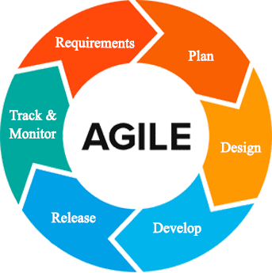

Figure 2: **Agile Development Methodology**

Figure 2 shows the representation of the framework lifecycle in an agile development methodology. The agile process requires less preparation, and the activities split into small increments. The agile process is for short-term projects with a team effort that meets the life cycle of software development (Sharma, 2012). By using customer feedback to agree on ideas, iteratively improves software This approach provides opportunities for assessing the path throughout the development lifecycle This performs by generic workflows, such as sprints or cycles to the end of which teams deliver a material increment that is potentially transmittable. This approach focuses on the replication of abbreviated work cycles and the functional yields of the product.

The developers do the following phases of the Agile Methodology:

**Requirement Analysis.** Defined the requirements for the iteration based on the product backlog, sprint backlog, customer and stakeholder feedback.

The gathered system features are from research and interviews conducted with industry experts in the related fields. The User Interfase (UI) designer and the programmer defined the code specifications needed to fulfill the requirements of the project. The technical writer then took note of changes and checked the document with all team members present. The database designer verified if the features are compatible with the materials. The project manager reported the improvements made by the team to the team's adviser.

Initially, the team members made the primary manuscript and background researches on learning centers, educators, and job-seekers to lay out the things to do. In every iteration, the team members assigned to work on the obstacles analyzed the issues and came up with a possible solution. They consulted on resolutions with the other members. At the end of each day, the team members reported on their progress.

**Plan Phase.** Phase of preparation involved creating a set of plans that helped guide the team through the phases of project implementation and closure. The plans produced during this process helped developers manage time, cost, performance, change, risk, and issues to ensure the project is delivered on time and within budget by the developers.

The team determined schedules, preparations, and plans of actions to handle changes during the iteration. In every sprint cycle, the organizations made are directed towards the fulfillment of its intentions. Itemized priorities and time constraints were the focus of budget allocation by the project manager. The team established communication routes for questions and issues that arose.

**Design Phase.** The specifications evaluated and defined by the designers are used in the design phase to make design choices using various diagrams. The assigned UI designer created the user interface. The programmer and database designer described the device element interface mechanism. The project manager monitored the progress of the members' tasks. From the selected sprint backlog, the team determined which designs to tackle from the manuscript. There is a parallel development of mobile and web applications.

**Development Phase.** This step required testing usability and reliability for all aspects of the product. The software testing checked if it met all the specifications set out in the evaluation of requirements and if it handled the information correctly.

The developers checked, analyzed, identified the issues and updated or modified the software beyond the steps or requirements that were set up. Until deployment, all parts of the operation underwent a continuum of individual evaluations through different testing methods to ensure its efficacy and efficiency.

**Release.** Before releasing it to the market, developers carried out several activities to test the application. It allowed the system to work within each operation of the deployment phase with tolerable performance and specific processes. Using the guidance given in the deployment document, developers then installed the application in the server environment.

**Track and Monitor.** This phase happened after the program is sent out to the customers/clients. Here, developers maintain tracking, monitoring, and providing IT support services to include system and software updates and enhancements if appropriate. Feedback gathered from monitoring generates a list of improvements and bug fixes for the next iteration.

Another sprint cycle happens at the end of the previous. A sprint review with all members determines the set of activities for the next iteration. It includes adjustments from leftover unfinished tasks, additional features requested, and feedback from monitoring.

**Planning/Conception-Initiation Phase**

The planning phase discussed the high-level decisions on why a project is valuable and what the requirements are. It helped the researchers keep track of assigned tasks, meeting deadlines, the progress of each requirement, and the budget for project work plans.

**Business Model Canvas**

The Business Model Canvas is a visual representation, commonly used by strategic managers, of existing and emerging business models.

Table 2

BUSINESS MODEL CANVAS

|  |  |  |  |  |  |  |
| --- | --- | --- | --- | --- | --- | --- |
| **KEY PARTNERS** | **KEY ACTIVITIES** | **VALUE PROPOSITIONS** | | | **CUSTOMER RELATIONSHIPS** | **CUSTOMER SEGMENTS** |
| * Learning Centers * Educators currently teaching in learning centers * Job seeking educators | * Design and develop an intelligent school management software geared towards the needs of learning centers, educators and students | | * System can be used by any type of learning center * System could automate basic operations of administration with integrated artificial intelligence * Recommend job vacancies to educators * Assist educators in classes * Market learning center services and recommend courses to student | | * Customer service hotlines * User Feedback * Email | * Learning center administration * Educators in learning centers * Students in learning centers * Educators seeking employment |
| **KEY RESOURCES** | | **CHANNELS** |
| * Developers. * Cloud-based database storage and back-end. * Internet * Android smart phones * Software Development Toolkit | | * Social Media platforms * Digital Ads * Word of Mouth |
| **COST STRUCTURE** | | **REVENUE STREAM** | | | | |
| * Customer acquisition costs * Research and Development * Marketing and Advertising * Hosting, Operations and Maintenance | | | | * Subscription based on feature packages * Ad Revenue from free or trial users | | |

Table 2 illustrates the Business Model Canvas of the system. The Business Model Canvas is essential in building a flourishing business market. It gives concrete ideas to the researchers about the target market of the project and the cost of developing it. The Value Proposition shows the importance it gives to the public. Channels are a way for the group to interact simultaneously with customers and investors to sell the program. Customer relationships ensure that the entities involved are supporting our business relationship. Revenue streams demonstrates how we can earn revenue from the services provided.

**Program Workflow**

Defining, managing, automating and optimizing business processes is a software workflow. Progressions of measures (tasks, events, interactions) involving a cycle of work, involving two or more individuals, and generating or adding value to the activities of the organization.

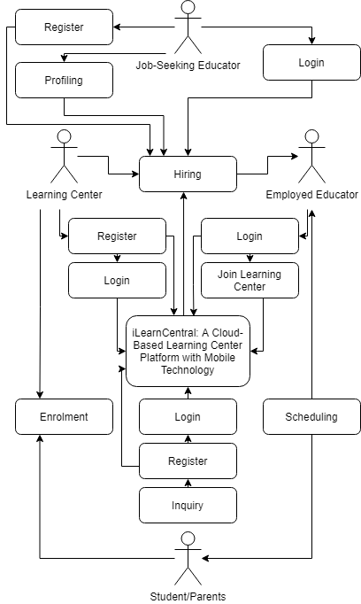

Figure 3: **User Activity Program Workflow**

Figure 3 shows the program workflow for general user activities. The administrative account creation and authentication starts with the registration of learning centers to the system. Job seekers register for an account to build their profile resume. The hiring module involves the learning center and job-seeking educator which could produce an employed educator. Only learning center and educator accounts can log in to most of the functionalities of iLearnCentral. Interested students can inquire by creating a free account and browse through services offered by learning centers. Enrollment would involve input from both learning center and the student. The scheduling is processed by iLearnCentral to produce calendars to the educator and student.

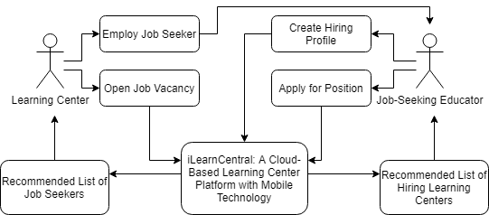

Figure 4: **Hiring Module Program Workflow**

Figure 4 details the hiring module from Figure 3. Job-seeking educators build their hiring profile or resume. After which the system processes their qualifications and determine a list of hiring learning centers from open job vacancies on which they apply for. They can also browse through other job vacancies available. On the other hand, learning centers receive recommended list of job-seeking profiles which fit their requirements.

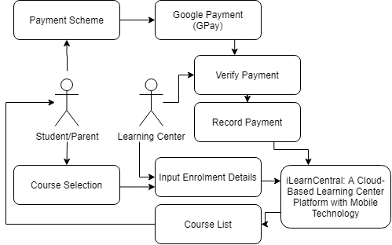

Figure 5: **Enrollment Module Program Workflow**

Figure 5 shows the program workflow for the enrollment module. The student or parent sees a list of courses from the system provided by the chosen learning center. With the selected course/s, they can process enrollment by providing the required information. The system prompts the Google Payment(GPay) form for online payment and receives a receipt that will verify enrollment fee once payment is sucessful. The student will then send out a soft copy of the receipt to the admin to verify their enrollment.

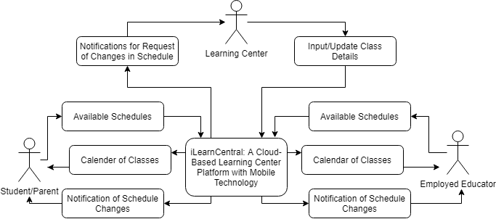

Figure 6: **Scheduling Module Program Workflow**

Figure 6 shows the workflow for the scheduling module. The administrative staff would input class details for scheduling. The students and educators have time available when they can have a class. Schedules depend on matches with classes and educator’s open loads. There should be a consideration for the classrooms available and the learning center’s open business hours. Any changes to the schedule automatically adjusts schedules and notify all persons involved.

**Validation Board (Stages 1 and 2)**

Table 3 shows the different problems that our customers encountered. It also shows the solution to the problem being solved by the researcher. Table 3 also contains the most risky assumption, the methods and the criteria for success, the results and the decision, as well as the learning.

Table 3

VALIDATION BOARD

|  |  |  |  |
| --- | --- | --- | --- |
| Experiments | 1 | 2 | 3 |
| Customer | Learning Center Administration | Educator | Job-Seeking Educators |
| Problem | Learning centers using manual transactions to support common management processes i.e. hiring, enrollment, and scheduling | Variation of lessons for different students handled, maintaining schedules, and keeping records | High turnover of educators in learning centers leading to constant demand amidst particular qualifications. |
| Solution | A dynamic learning center management system supporting different types of learning centers, i.e. day care, music, language studies | Adding a module for educators employed by a center to keep track of lessons, update schedules, and integrate records to the system. | Data pool of job-seeking educators sifted and recommended to fit learning centers' particular needs and vice versa. |
| Riskiest Assumption | Learning Center have no IT support | Learning center provide resources i.e. internet connectivity to employees | Educators uses the system to look for employment in learning centers |
| Method and Success Criteria | 60% of the respondents agree to use the system | 60% of the respondents agree to use the system | 60% of the respondents agree to use the system |

**Gantt Chart**

The Gantt chart shows the scheduled work or activity completion in specific time frames in relation to the amount planned for the specified periods. The chart serves as a guide for the advocates to decide how long a project takes, classify the resources needed, and schedule the order of task completion performed by the researchers.

Table 4

GANTT CHART

|  |  |  |  |  |  |  |  |  |  |  |  |  |  |  |  |  |  |  |  |  |
| --- | --- | --- | --- | --- | --- | --- | --- | --- | --- | --- | --- | --- | --- | --- | --- | --- | --- | --- | --- | --- |
| Task ID | Task Name | Task Lead | Start Date | End Date | September 2020 | | | | October 2020 | | | | November 2020 | | | | December 2020 | | | |
| 1 | 2 | 3 | 4 | 1 | 2 | 3 | 4 | 1 | 2 | 3 | 4 | 1 | 2 | 3 | 4 |
| 1 | AI | Rhea Shane | Sept. 1 | Nov. 13 |  |  |  |  |  |  |  |  |  |  |  |  |  |  |  |  |
| 2 | Development / Construction / Build Phase | Rhea Shane | Sept. 1 | Nov. 30 |  |  |  |  |  |  |  |  |  |  |  |  |  |  |  |  |
| 3 | Technology  Stack Diagram Specification | Jephunneh | Sept. 1 | Sept. 4 |  |  |  |  |  |  |  |  |  |  |  |  |  |  |  |  |
|  |  |  |
| 4 | Software Requirements Specification | Jephunneh | Sept. 1 | Sept. 4 |  |  |  |  |  |  |  |  |  |  |  |  |  |  |  |  |
|  |  |  |
| 5 | Testing/Quality Assurance Phase | Cristian | Sept. 1 | Dec. 4 |  |  |  |  |  |  |  |  |  |  |  |  |  |  |  |  |
|  |
| 6 | Unit Testing | Cristian | Sept. 1 | Dec. 4 |  |  |  |  |  |  |  |  |  |  |  |  |  |  |  |  |
| 7 | Integration Testing | Cristian | Dec. 1 | Dec. 3 |  |  |  |  |  |  |  |  |  |  |  |  |  |  |  |  |
| 8 | Alpha Testing | Cristian | Dec. 1 | Dec. 3 |  |  |  |  |  |  |  |  |  |  |  |  |  |  |  |  |
| 9 | Acceptance Testing | John Rey | Oct. 12 | Oct. 23 |  |  |  |  |  |  |  |  |  |  |  |  |  |  |  |  |
| 10 | Cost Specification | John Rey | Oct. 12 | Oct. 23 |  |  |  |  |  |  |  |  |  |  |  |  |  |  |  |  |
|  |  |  |  |  |  |  |  |  |  |  |  |  |  |  |  |  |  |  |  |  |
| 11 | Implementation/Deployment Phase | Rhea Shane | Dec. 7 | Dec. 11 |  |  |  |  |  |  |  |  |  |  |  |  |  |  |  |  |
| 12 | Human  Resource Specifications | Jephunneh | Sept. 1 | Sept. 4 |  |  |  |  |  |  |  |  |  |  |  |  |  |  |  |  |
| 13 | User & Installation Guide | John Rey | Dec.1 | Dec. 11 |  |  |  |  |  |  |  |  |  |  |  |  |  |  |  |  |
| 14 | Project Roadmap | Jephunneh | Sept. 1 | Nov. 30 |  |  |  |  |  |  |  |  |  |  |  |  |  |  |  |  |
|  |
| 15 | Conclusion | Jephunneh | Dec. 14 | Dec. 18 |  |  |  |  |  |  |  |  |  |  |  |  |  |  |  |  |
|  |
| 16 | Recommendations | John Rey | Oct. 12 | Oct. 23 |  |  |  |  |  |  |  |  |  |  |  |  |  |  |  |  |
| 17 | Finalization  of  Manuscript and Proposal | John Rey | Oct. 12 | Dec. 11 |  |  |  |  |  |  |  |  |  |  |  |  |  |  |  |  |

Table 4.1

GANTT CHART CONT’D

**Complete** **Ongoing** **Not yet started**

Table 4 shows the Gantt chart of the development for the proposed project. Every activity is performed in three different colors: red means that the activity has not yet started, yellow means that the activity is still on the way, and blue means that the activity is already finished.

**Functional Decomposition Diagram**

The functional decomposition diagram demonstrates the operative relationship between the various components of the project into critical modules to clearly illustrate and simplify various activities.

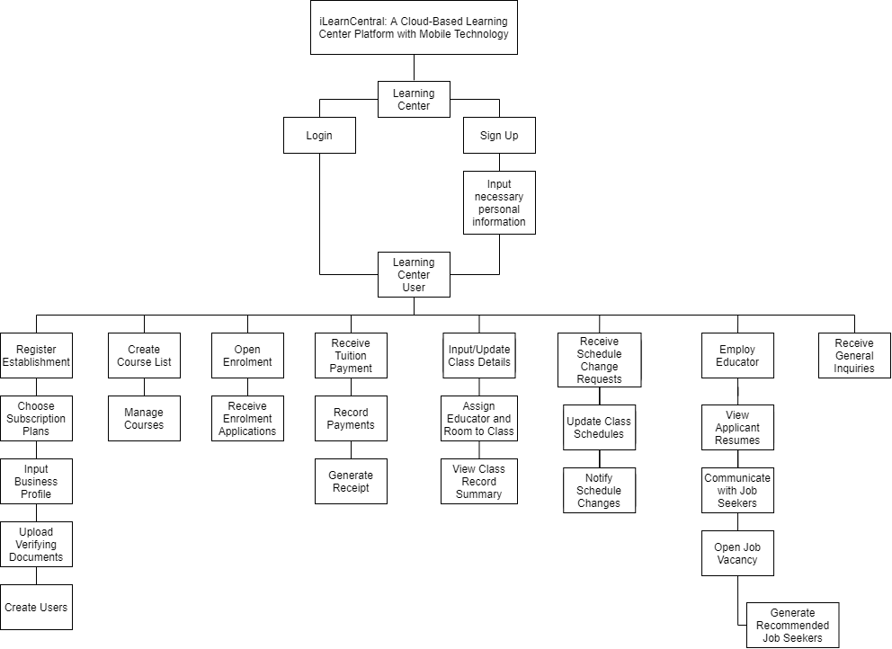

Figure 7: **Functional Decomposition Diagram (Learning Center)**

Figure 7 shows the functional decomposition diagram of the learning center user. The learning center will have the administrator account access since the user will manage the users their educators and other employees will have. Also, the user can create a course list which the students can enroll to. The administrator can also handle rescheduling and updating changes while being notified also by changes made. Lastly, the administrator can receive tuition payments and generate receipts from enrolled students and can receive and return general inquiries.

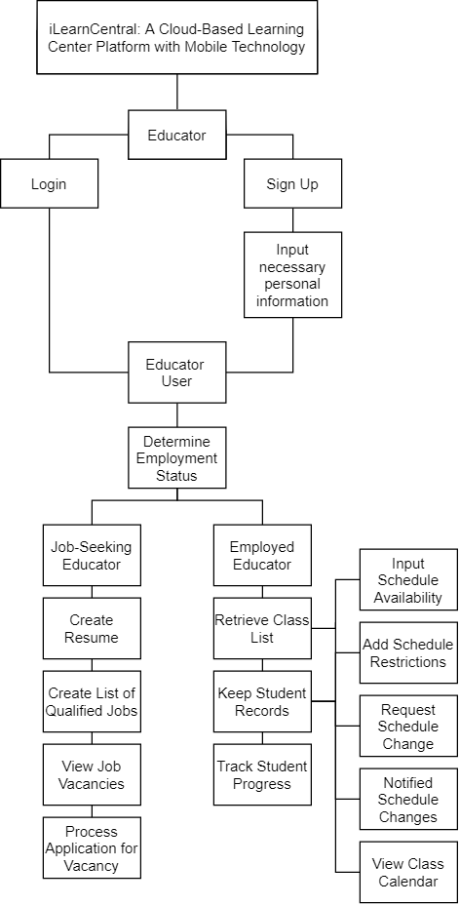

Figure 8: **Functional Decomposition Diagram (Educator)**

Figure 8 shows the functional decomposition diagram of the educator user. The educator user will have to determine which account type they would like to possess, either job-seeking type educator account or the educator account. The job-seeking educator needs to create a resume or an application letter to be sent to learning centers that has posted a job vacancy. Then, apply for the vacancy by processing the application for the job. However, if the account is the educator account, the user will automatically be registered to the learning center they are under to and handle class and keep student records.

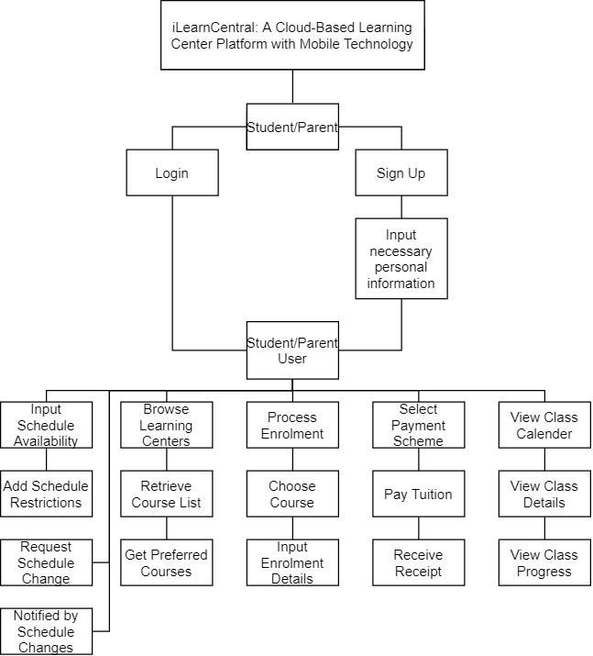

Figure 9: **Functional Decomposition Diagram (Student)**

Figure 9 shows the functional decomposition diagram of the student or parent user. The user will need to input their schedule availability to determine which schedules will be suitable for them to enroll. The student or parent can also process enrollment by selecting their preferred course or referred course by their educator. Also, by processing enrollment, they will have the comfort of paying the enrollment fee through the application.

**Analysis / Design Phase**

The stage of analysis includes the concept of the specifications needed to accomplish the method. Each step determines the problem to be solved by the customer.

**Use Case Diagram**

Use case diagram shows the graphic representation of the mechanism of iLearnCentral and potential sequences of interactions between systems and users in a specific environment related to a specific target.

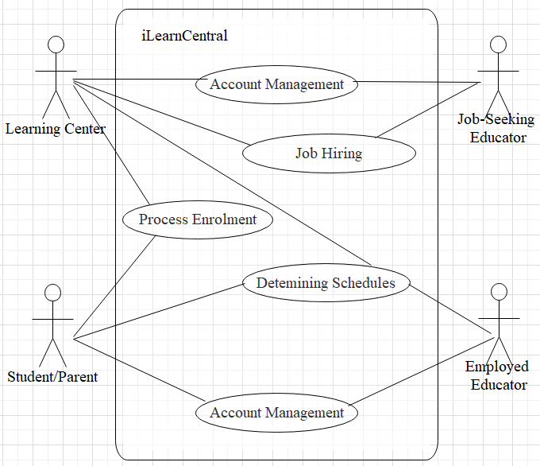

Figure 10: **Use Case Diagram**

Figure 10 shows the use case diagram for iLearnCentral. It shows the outside view of the system and the requirements needed. It identifies the system's influencing external and internal factors and their interactions.

The learning center is a factor in most of the internal modules. Account management involves all actors with varying degrees of complexity for each actor. Job hiring only concerns with the learning center and the job-seeking applicant. Enrollment processing is between the learning center and the students/parents. Determining schedules need the interaction between the learning center, student, and assigned educator.

**Storyboard**

This section shows the graphic organizer of the iLearnCentral application in the form of images being displayed by sequence of their appearance for each users through navigating the application.

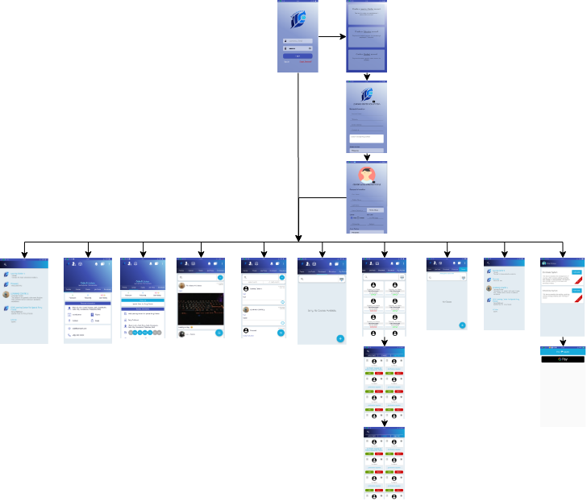

Figure 11: **Storyboard (Learning Center)**

Figure 11 shows the graphical presentation of the learning center user. The first page of the application is the login page, in which the user is prompted to enter user credentials. If the user still has no existing account, they may create an account and enter personal information. Upon success of entering user credentials, the user will reach the main page of the learning center user. This page contains the profile, about center, feeds, job posts, enrolment, educators, and classes page.

Also, the learning center user may also apply for the existing systems the application has, which is the enrolment and scheduling systems. For this, payment must be done first through GPay (Google Pay) to access the system and use the functions of the system.

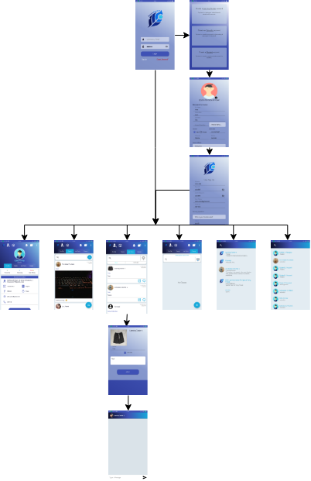  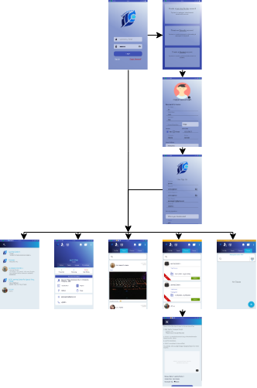

Figure 11.1: **Storyboard (Educator and Students)**

Figure 11.1 shows the graphical presentation of the educator and student users. Both users will still be prompted to enter user credentials if they already have existing accounts. If user still has no existing account, they may create and account and enter personal information. Upon success of entering user credentials, both users will reach each main pages of each users.

For the educator user, the main page contains profile, feeds, job posts, and classes page. The educator user may apply for a job post when the educator is yet to find a learning center to work for. First, they will complete their personal information as well as resume for employers to view. When they apply for a job opening, the employers can view their personal background upon completion of resume.

For the student user, the main page contains profile, feeds, courses, and classes page. The student user may enroll to a course posted by the learning center or educator once their account is verified by the learning center admin. Also, updates and postings made by the learning center and educators can be viewed from the student user account.

**User Interface Diagram**

This section shows a visual representation of the real mobile implementation focusing on maximizing usability and user experience. It shows how the user can communicate with the computer (Android device) and visually demonstrate the characteristics or functions that users can use depending on the user type.

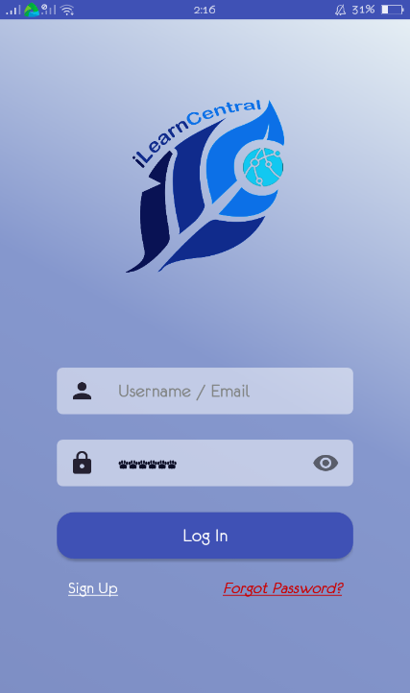

Figure 12: **Login Page**

Figure 12 shows the Login Page. The user can enter their credentials to login. This page also provides links to the registration page and forgot password support page.

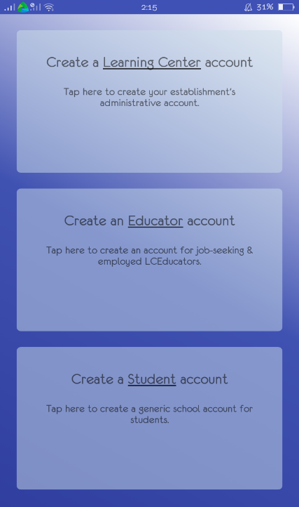

Figure 13: **Account Type Selection Page**

There are three type of users – educator, student and learning center. Users can select the type of account they would like to create.

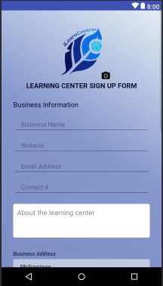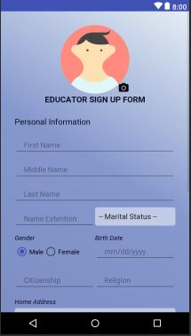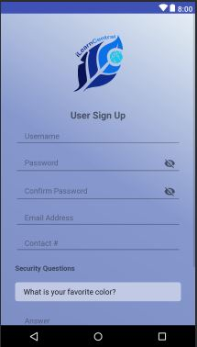

Figure 14: **Sign up Page**

Figure 14 shows the different pages for each of the user sign up types. The sign up page for learning centers is different from the educator and student because the sign up for learning centers require them to specify the type of learning center that they have. The pages show required information for the registration (e.g. First Name, Middle Name, Last Name, Username and Password). Once filled out, users can click on ‘Register’ button to complete the registration or to cancel by clicking the ‘Cancel’ button.

**Learning Center User Interface**

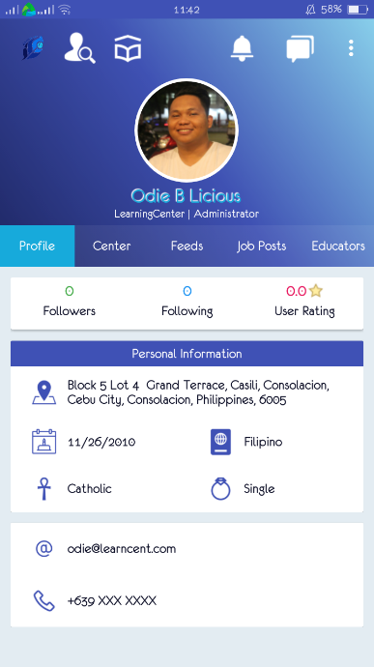

Figure 15: **Learning Center Profile Page**

Figure 15 shows the profile of a learning center. This includes the number of employees, students, followers and contact information.

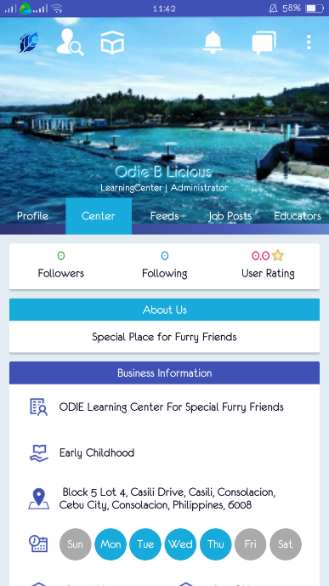

Figure 16: **Learning About Center Page**

Figure 16 shows the information about the learning center. This includes the business information, location and business schedule.

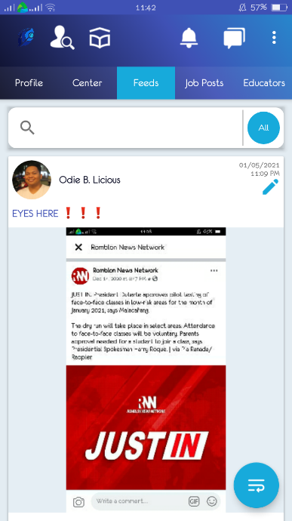

Figure 17: **Learning Center Feed Page**

Figure 17 shows the feed or posts about other existing learning centers. Only learning centers existing under the system can view and post under feeds page.

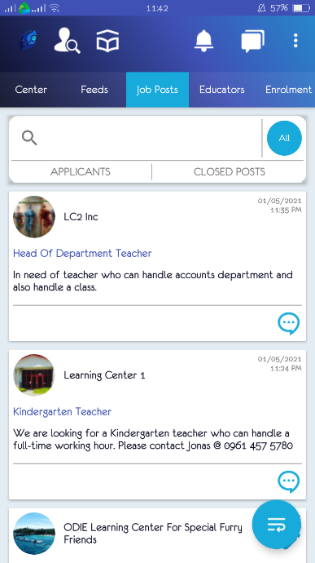

Figure 18: **Learning Center Job Posts Page**

Figure 18 shows the job posts by learning centers including the user given if the user also posted a job post.

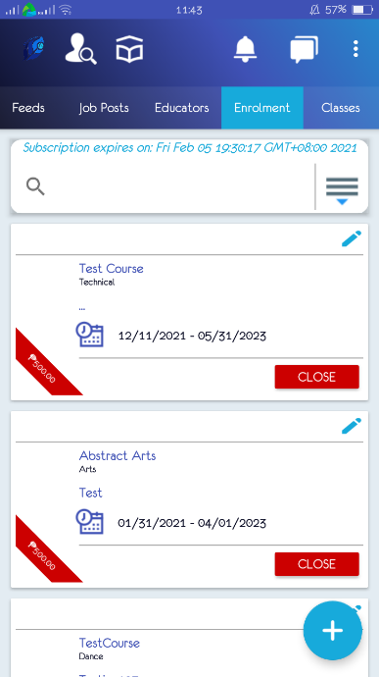

Figure 19: **Learning Center Enrollment Page**

Figure 19 shows the enrollment page where learning centers can post a subject that students can enroll.

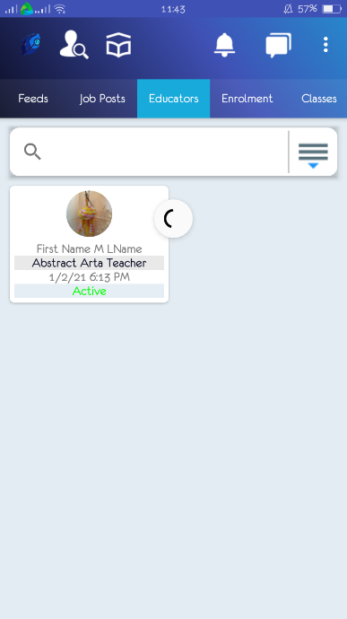

Figure 20: **Learning Center Educators Page**

Figure 20 shows the educators’ page where the learning center user can view their educator as well as their status and other information.

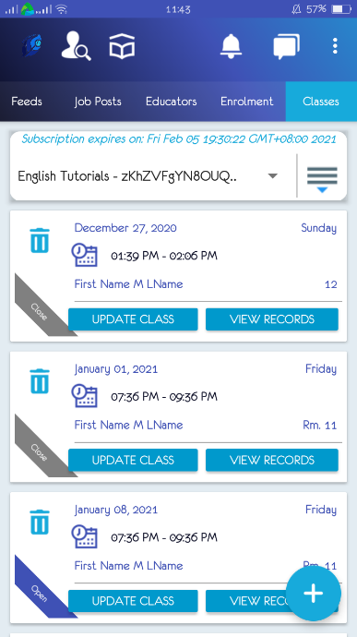

Figure 21: **Learning Center Classes Page**

Figure 21 shows the classes of the day. In here, the classes will be shown with the subject and the educator assigned to the subject.

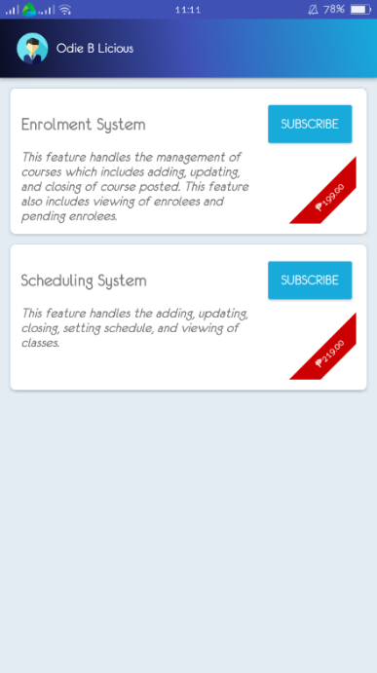

Figure 22: **Learning Center Enrollment and Scheduling Subscription Page**

Figure 22 shows the enrollment and scheduling function the learning center can use for ease of usage of their users.

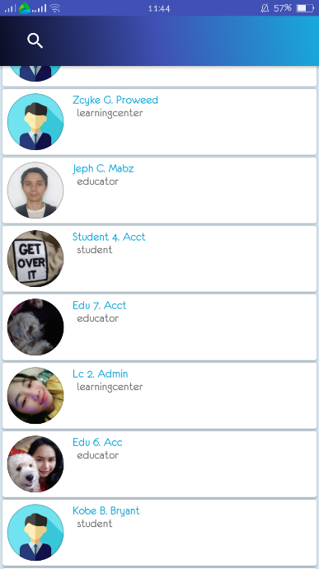

Figure 23: **Learning Center Search Page**

Figure 23 shows the search page in which the user can search for a user existing in the system.

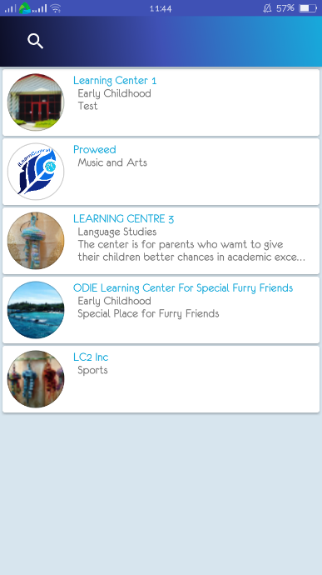

Figure 24: **Learning Center Recommended Learning Centers Page**

Figure 24 shows the list of recommended learning centers for the users. In here, it is also shows their information. They can also be searched if the user wants to know more about their interested learning center.

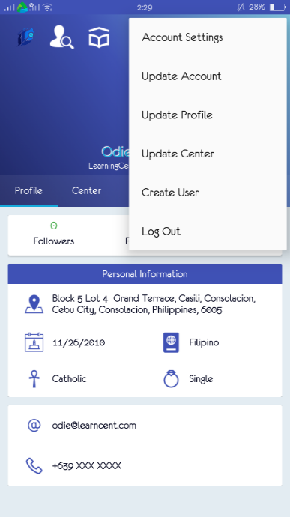

Figure 25: **Learning Center Sidenav Page**

Figure 25 shows the side navigation bar page of the system and other options for the application.

**Educator User Interface**

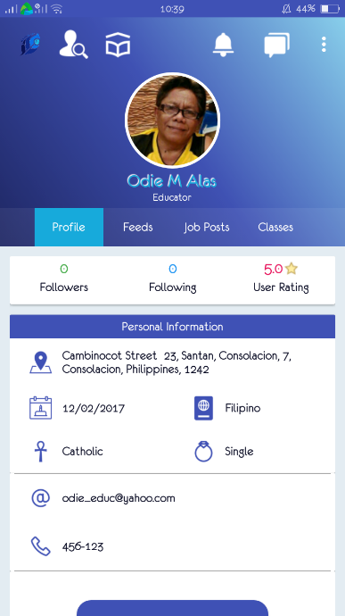

Figure 26: **Educator Profile Page**

Figure 26 shows the profile page of the educator user. They can view their personal information as well as update their information for their future employers.

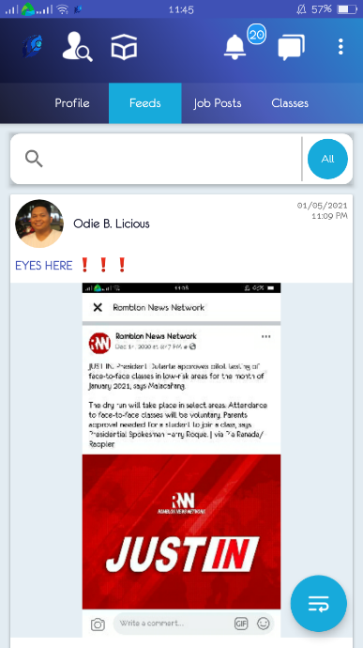

Figure 27: **Educator Information Feeds Page**

Figure 27 shows the feeds page of the educator user. They can view updates or information in regards to the shared information of learning centers, fellow educators, or students to their information feed.

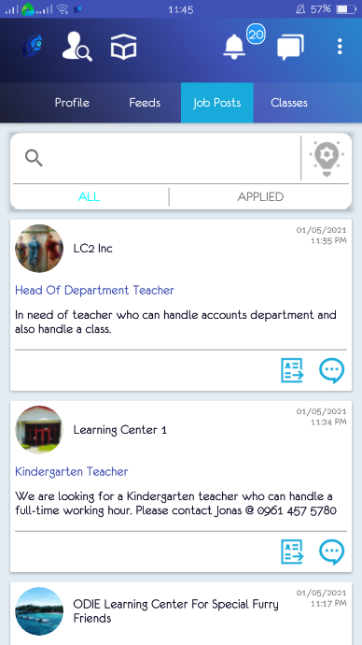 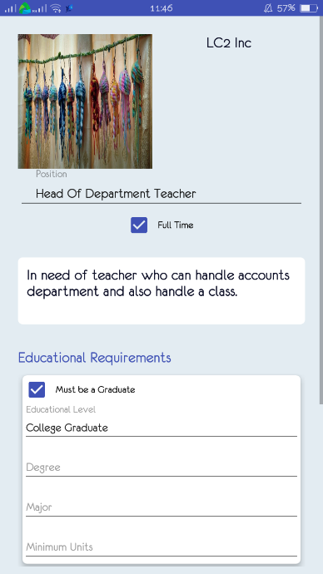 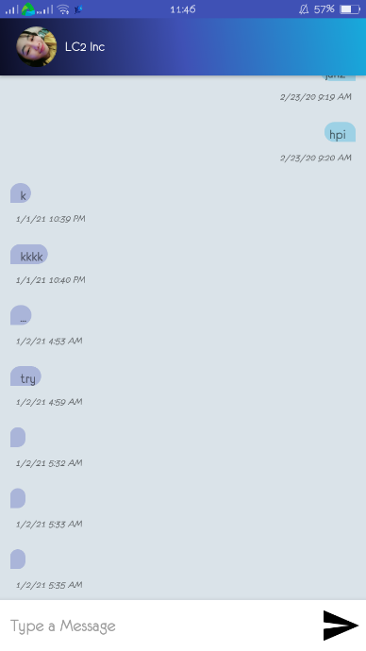

Figure 28: **Educator Job Posts Page**

Figure 28 shows the job posts page of the educator user. In here, the educator can view any job openings posted by learning centers they are following/updated to. Also, they can apply and try to contact the employer of the said job opening.

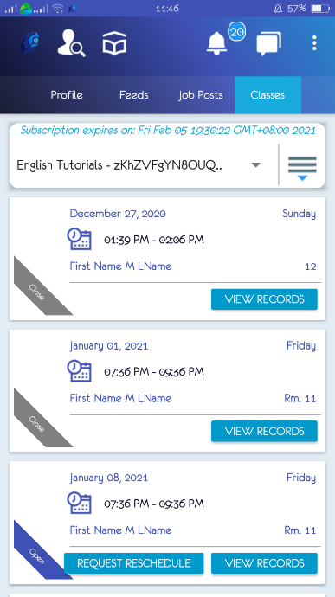

Figure 29: **Educator Classes Page**

Figure 29 shows the classes page of the educator user. In here, the educator can view their class schedules for the entire day.

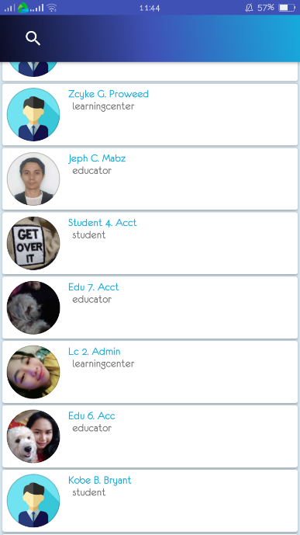

Figure 30: **Educator Search Page**

Figure 30 shows the search page of the educator user. The educator can search any existing user of the application.

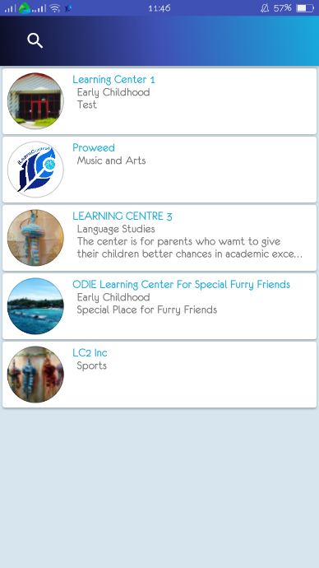

Figure 31: **Educator Learning Centers Page**

Figure 31 shows the list of existing learning centers that have applied for the application. In here, the educator can view all the information they want to know about the existing learning centers.

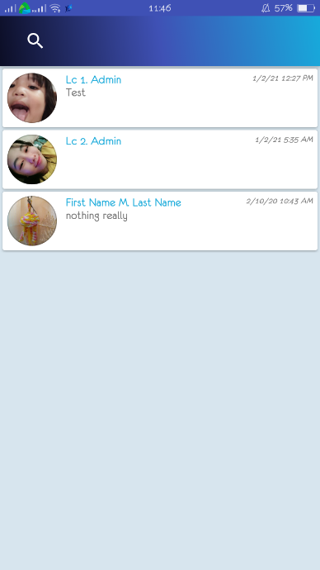

Figure 32: **Educator Message Page**

Figure 32 shows the messaging page of the educator user. In here, they can message members that are only authorized for them to send a message to.

**Student User Interface**

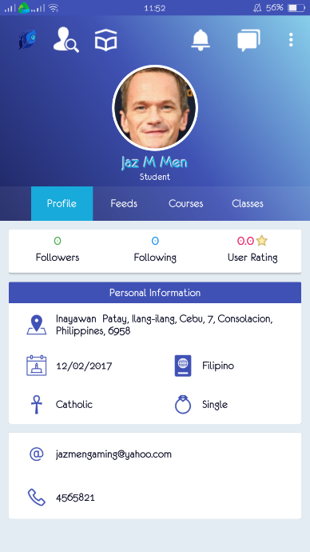

Figure 33: **Student Profile Page**

Figure 33 shows the profile page of the student user. The user can view their personal information that are viewed by other users.

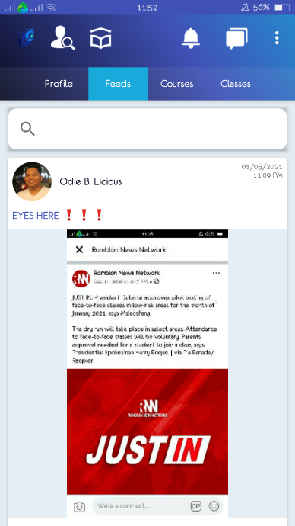

Figure 34: **Student Information Feeds Page**

Figure 34 shows the information feed of the student user. In here, the user can view any information update posted by other users the student are updated/following to.

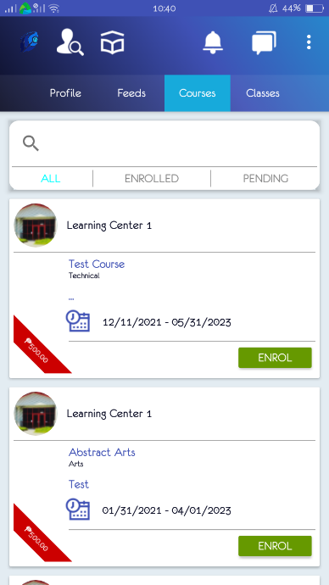 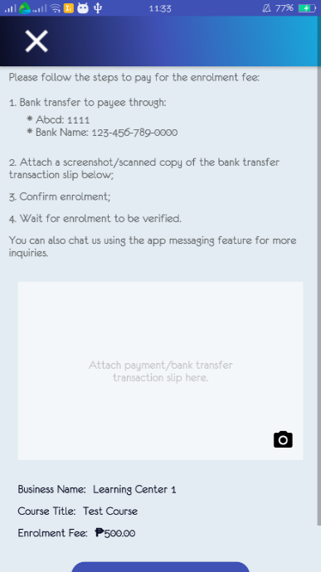

Figure 35: **Student Courses Page**

Figure 35 shows the courses page of the student user. The user can view the courses intended for them to enroll or instructed by the learning center or educator.

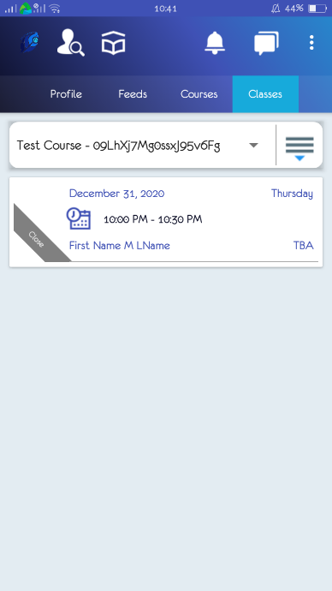

Figure 36: **Student Classes Page**

Figure 36 shows the classes page of the student user. In here, the user can view their classes throughout the whole day.

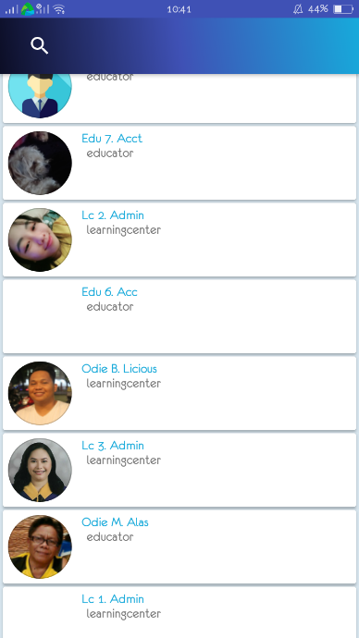

Figure 37: **Student Search Page**

Figure 37 shows the search page of the student user. The user can search any existing member of the application.

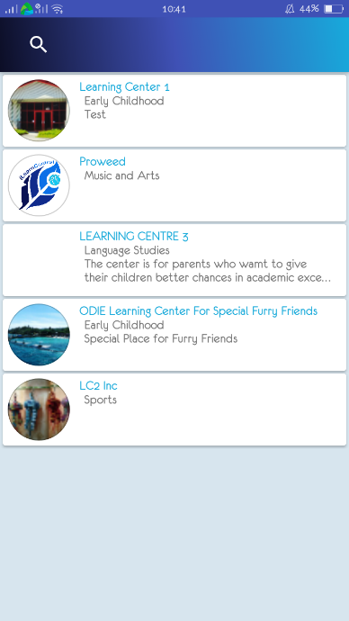

Figure 38: **Student Recommended Learning Centers Page**

Figure 38 shows the list of recommended learning centers of the application. In here, the user can view all the information and any other information the user wants to know.

**Database Design**

The database to use is NoSQL due to the advantages it provides with data volume, velocity, and variety. It allows for better adaptability to changes in schema when using agile development. It is scalable and accessible to multitudes of users, which is necessary to a cloud-based system.

This section shows the designed NoSQL schema. The designing process follows the Query Driven Design that optimizes access instead of storage. It is by no means the final structure of the schema as changes may arise during the development process.

A document-oriented database, one of the main categories of NoSQL databases, is a computer program designed to store, retrieve, and handle document-oriented information, also known as semi-structured data. It is inherently a subclass of the key-value store and relies on an internal structure in the document to extract metadata that the database engine uses for further optimization. The current list of features in the documents presented in this section are basic details and more can be added or altered depending on the progress during development phase.

Table 5

USER DOCUMENT

|  |  |  |
| --- | --- | --- |
| **User** | | |
|  | AccountStatus | |
|  | AccountType | |
|  | ContactNo | |
|  | Email | |
|  | Following [ ] | |
|  | Followers [ ] | |
|  | Image | |
|  | Ratings [ ] | |
|  | SecurityQuestions [ ] { } | |
|  |  | Question |
|  | Answer |
|  | UserID | |
| PK | Username | |

Table 5 is the document database design for all user accounts. The collection of users is solely for account management. Depending on the type of account type, the system proceeds differently. The security questions are the means to provide validation in the event of resetting or retrieving forgotten passwords.

Table 6

LEARNING CENTER DOCUMENT

|  |  |  |
| --- | --- | --- |
| **Learning Center** | | |
| PK | CenterID | |
|  | Accounts [ ] { } | |
|  |  | AccessLevel |
|  | Status |
| FK | Username |
|  | BankAccounts [ ] { } | |
|  |  | AccountName |
|  | BankName |
|  | BusinessAddress { } | |
|  |  | Barangay |
|  | City |
|  | Country |
|  | District |
|  | HouseNo |
|  | Province |
|  | Street |
|  | ZipCode |
|  | BusinessName | |
|  | ClosingTime | |
|  | CompanyWebsite | |
|  | ContactEmail | |
|  | ContactNumber | |
|  | Description | |
| FK | Followers [ ] | |
|  | Logo | |
|  | OpeningTime | |
|  | OperatingDays [ ] | |
|  | Ratings { } | |
| FK |  | Username |
|  | Rating |
|  | ServiceType | |

Table 6 is the document database design for learning center entities. It records the information about learning centers, including data on identity, operating hours, and subscription to the system. The address is necessary to have segmented documentation for easier processing by the recommendation system in the hiring module.

Table 7

LEARNING CENTER STAFF DOCUMENT

|  |  |  |
| --- | --- | --- |
| **Learning Center Staff** | | |
| PK | LearningCenterStaffID | |
|  | AccessLevel | |
|  | Address { } | |
|  |  | Barangay |
|  | City |
|  | Country |
|  | District |
|  | HouseNo |
|  | Province |
|  | Street |
|  | ZipCode |
|  | Birthday | |
| FK | CenterID | |
|  | Citizenship | |
|  | Gender | |
|  | MaritalStatus | |
|  | Name { } | |
|  |  | Extension |
|  | FirstName |
|  | LastName |
|  | MiddleName |
|  | Religion | |
| FK | Username | |

Table 7 is the document database design for learning center staff entities. It holds the primary information of learning center staff. The accompanying centerID determines the learning center that employs the staff.

Table 8

EDUCATOR DOCUMENT

|  |  |  |
| --- | --- | --- |
| **Educator** | | |
| PK | EducatorID | |
|  | Address { } | |
|  |  | Barangay |
|  | City |
|  | Country |
|  | District |
|  | HouseNo |
|  | Province |
|  | Street |
|  | ZipCode |
|  | Birthday | |
| FK | CenterID | |
|  | Citizenship | |
|  | EmploymentDate | |
|  | EmploymentStatus | |
|  | EmploymentType [ ] | |
|  | Gender | |
|  | MaritalStatus | |
|  | Name { } | |
|  |  | Extension |
|  | FirstName |
|  | LastName |
|  | MiddleName |
|  | Position | |
|  | Religion | |
| FK | Username | |

Table 8 is the document database design for educator entities. It holds the primary information of an educator and represents educators. The employment status and accompanying centerID determines the state of an educator.

Table 9

RESUME DOCUMENT

|  |  |  |
| --- | --- | --- |
| **Resume** | | |
| PK | ResumeID | |
|  | Awards [ ] | |
|  | CareerObjective | |
|  | EducationalBackground [ ] { } | |
|  |  | Course |
|  | EducationLevel |
|  | Graduated |
|  | Major |
|  | SchoolName |
|  | SchoolAddress |
|  | SchoolYear |
|  | EmploymentHistory [ ] { } | |
|  |  | CompanyName |
|  | CompanyAddress |
|  | DateEnd |
|  | DateStart |
|  | Position |
|  | Interests [ ] | |
|  | Qualities [ ] | |
|  | References [ ] { } | |
|  |  | ReferenceName |
|  | Affiliation |
|  | Position |
|  | ContactInfo |
|  | Skills [ ] | |
| FK | Username | |

Table 9 is the document database design for resume entries. It represents the accompanying resume of an educator account and provides the usual information about a job seeker.

Table 10

STUDENT DOCUMENT

|  |  |  |
| --- | --- | --- |
| **Student** | | |
| PK | StudentID | |
|  | Address { } | |
|  |  | Barangay |
|  | City |
|  | Country |
|  | District |
|  | HouseNo |
|  | Province |
|  | Street |
|  | ZipCode |
|  | Birthday | |
|  | CenterID | |
|  | Citizenship | |
|  | EnrolmentStatus | |
|  | Gender | |
|  | MaritalStatus | |
|  | Name { } | |
|  |  | Extension |
|  | FirstName |
|  | LastName |
|  | MiddleName |
|  | Religion | |
| FK | Username | |

Table 10 is the document database design for student entities. Parents and students get one account in our system as they do not have a difference in functionalities directed to them. The expectation is for parents to handle the account for minor students. The document also contains the enrollment history of the student.

Table 11

JOB VACANCY DOCUMENT

|  |  |  |
| --- | --- | --- |
| **Job Vacancy** | | |
| PK | VacancyID | |
|  | ApplicationMethod [ ] | |
| FK | CenterID | |
|  | Date | |
|  | EducationalRequirements [ ] { } | |
|  |  | Degree |
|  | EducationalLevel |
|  | Graduated |
|  | Major |
|  | MinimunUnits |
|  | JobDescription | |
|  | JobType [ ] | |
|  | Position | |
|  | Qualifications [ ] | |
|  | Responsibilities [ ] | |
|  | Skills [ ] | |
|  | Status | |
| FK | Username | |

Table 11 is the document database design for job vacancy events. The job vacancy has to be made by a learning center. It has data on the position to be filled and all pertinent information required to qualify a job-seeker to the job.

Table 12

JOB APPLICATION DOCUMENT

|  |  |
| --- | --- |
| **JobApplication** | |
| PK | JobApplicationID |
|  | ApplicationDate |
|  | ApplicationStatus |
|  | Message |
| FK | Username |
| FK | VacancyID |

Table 12 is the document database design for job application events. A job application happens when a job seeker applies for an available job vacancy. The learning center receives a list of recommended applicants as well as job-seekers who manually applied.

Table 13

COURSE DOCUMENT

|  |  |
| --- | --- |
| **Course** | |
| PK | CourseID |
| FK | CenterID |
|  | CourseDescription |
|  | CourseFee |
|  | CourseName |
|  | CourseStatus |
|  | CcourseType |
| FK | Educators [ ] |
|  | ScheduleFrom |
|  | ScheduleTo |

Table 13 is the document database design for course entities. The courses are services offered by a learning center and the basis for enrollment and classes.

Table 14

ENROLLMENT DOCUMENT

|  |  |
| --- | --- |
| **Enrolment** | |
| PK | EnrolmentID |
| FK | CenterID |
|  | CourseEnrolled |
| FK | CourseID |
|  | DateCourseEnd |
|  | DateCourseStarts |
|  | DateEnrolled |
|  | EnrolmentFee |
|  | EnrolmentStatus |
|  | LearningCenterName |
|  | ProcessedDate |
| FK | StudentID |
|  | StudentName |

Table 14 is the document database design for enrollment events. Details of an enrollment process are stored here. Information about the learning center and student involved retrieves from their document store via foreign keys.

Table 15

PAYMENT DOCUMENT

|  |  |  |
| --- | --- | --- |
| **Payment** | | |
| PK | PaymentID | |
|  | AdditionalFees | |
|  | Balance | |
| FK | EnrolmentID | |
|  | PaymentStatus | |
|  | Payments [ ] { } | |
|  |  | Amount |
|  | PaymentDate |
|  | PaymentMethod |
|  | Validated |
|  | Tuition |  |

Table 15 is the document database design for a payment plan. An entry of the payment document is a counterpart of an enrollment. It records the progress of payments made, be it one-time full payment or each staggering pay. The record also contains the details of the fees needed.

Table 16

CLASS DOCUMENT

|  |  |  |
| --- | --- | --- |
| **Class** | | |
| PK | ClassID | |
| FK | Activities [ ] | |
|  | Attendance [ ] { } | |
|  |  | Attendance |
|  | Remarks |
| FK | StudentID |
|  | ClassEnd | |
|  | ClassStart | |
| FK | CourseID | |
| FK | EducatorID | |
|  | LessonPlan | |
|  | LinkedPlan | |
|  | Message | |
|  | RoomNo | |
|  | Status | |

Table 16 is the document database design for a class. Class sessions contain details of meetups between students and educators. Learning centers are tasked to set up the classes.

Table 17

LESSON PLAN DOCUMENT

|  |  |
| --- | --- |
| **Lesson Plan** | |
| PK | LessonID |
|  | Activities [ ] |
| FK | CourseID |
|  | Materials [ ] |
|  | Objective [ ] |
|  | Overview |
|  | Procedures [ ] |
|  | Topic |

Table 17 is the document database design for lesson plans. It contains the different sections in building lesson plans. An educator may add multiple instances of each part. Lesson plans are reusable and shareable across educators within the learning center.

Table 18

STUDENT RECORD DOCUMENT

|  |  |  |
| --- | --- | --- |
| **StudentRecord** | | |
| PK | StudentRecordID | |
|  | Activities [ ] | |
|  | Classes [ ] { } | |
|  |  | Attendance |
| FK | ClassID |
|  | Remarks |
| FK | CourseID | |
| FK | StudentID | |

Table 18 is the document database design for student records. It means to keep track of student progress and data. It links to lesson plans and histories of sessions attended.

Table 19

CLASS ACTIVITY DOCUMENT

|  |  |  |
| --- | --- | --- |
| **ClassActivity** | | |
| PK | ClassActivityID | |
|  | ActivityDescription | |
|  | ActivityTitle | |
| FK | ClassID | |
|  | PerfectScore | |
|  | Scores [ ] { } | |
|  |  | Score |
| FK | StudentID |
|  | Students [ ] | |

Table 19 is the document database design for class activity. It means to keep track of student detailed progress and data with regards to activities in a class. It records test scores and description of the activity performed.

Table 20

MESSAGES DOCUMENT

|  |  |
| --- | --- |
| **Messages** | |
| PK | MessageID |
|  | DateSent |
| FK | From |
|  | Message |
| FK | To |

Table 20 is the document database design for messages. It records the differnt messages sent by users to each other. It is used for the chat feature and gives users a way to communicate.

Table 21

POST DOCUMENT

|  |  |
| --- | --- |
| **Post** | |
| PK | PostID |
|  | Content |
|  | Date |
|  | Fullname |
|  | Image |
|  | Title |
| FK | Username |

Table 21 is the document database design for posts. It is used in the optional feature of broadcasting to the public feed, giving opportunities for learning centers to advertise themselves and their activities.

Table 22

SEARCH HISTORY DOCUMENT

|  |  |
| --- | --- |
| **SearchHistory** | |
| PK | Username |
|  | Queries [ ] |

Table 22 is the document database design for search history. It keeps a record of a user’s search history and is used for the recommendation system.

Table 23

SUBSCRIPTION DOCUMENT

|  |  |
| --- | --- |
| **Subscription** | |
| PK | SubscriptionID |
|  | SubscriptionExpiry |
|  | SubsciprionLevel |

Table 23 is the document database design for subsription. It keeps all the subscription records of learning centers getting a subscription of the system. It is used to keep track the current state of subscription for each learning center and when they expire. The subscription level determines the availability of features a learning center can access.

Table 24

SALES DOCUMENT

|  |  |
| --- | --- |
| **Sales** | |
| PK | SalesID |
| FK | CenterID |
|  | Date |
|  | Fee |
|  | SubscriptionLevel |

Table 24 is the document database design for sales. It keeps a record of all sales the system generated from the learning center’s subscripitions.

**Entity-Relationship Diagram**

The entity-relationship diagram graphically demonstrates the interactions of entities, activities, events, and relationships across all modules of the system.

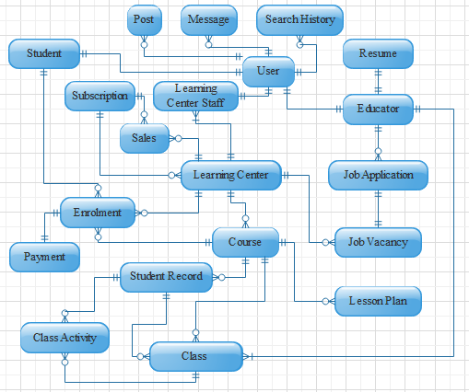

Figure 39: **Entity Relationship Diagram**

Figure 39 shows the entity-relationship diagram of the database of the application. The user is an entity that holds account management information used for login, password recovery, registration, and verification. Multiple user accounts are within a learning center with different access levels, while one user account per student and educator. The account management module handles user accounts.

The resume, job application, and job vacancy are document stores for profiling and hiring. Each educator is allowed to have one and only one resume. Meanwhile, learning centers can make multiple job vacancies for which educators can apply.

The enrollment module utilizes the course list and creates enrollment entries with payment instances. A single payment instance records the information for an enrollment's payment scheme and progress of installments.

The schedule request is the basis for scheduling classes. Class scheduling depends on the restrictions from students, educators, and learning centers. A student has classes from an enrolled course with many sessions assigned to one or different educators.

The teaching assistance involves the lesson plan and student record documents. The lesson plan segregates by course, while student records by enrollment.

**Data Dictionary**

The data dictionary describes the types of data, properties and field sizes shown in the tables in the previous section. The tables below are data dictionaries for each table in the database.

Table 25

DATABASE DATA DICTIONARY

|  |  |  |  |  |  |
| --- | --- | --- | --- | --- | --- |
| Table | **Key Name** | | **Data Type** | **Null** | **Description** |
| User | AccountStatus | | STRING | NOT NULL | status of the user |
| User | AccountType | | STRING | NOT NULL | determines the user account designation |
| User | ContactNo | | STRING | NULL | contact number of user |
| User | Email | | STRING | NULL | valid email address for verifying account |
| User | Following [ ] | | LIST | NULL | list of other users the user is following |
| User | Followers [ ] | | LIST | NULL | list of other users following the user |
| User | Image | | URL | NULL | link to the profile image of user |
| User | Ratings [ ] | | LIST | NULL | list of rating other people gave to the user |
| User | SecurityQuestions [ ] { } | | LIST | NOT NULL | array of security questions used for validating user identity |
| User |  | Question | STRING | NOT NULL | single security question |
| User | Answer | STRING | NOT NULL | answer to a security question |
| User | UserID | | STRING | NOT NULL | user id associated to authentication service |
| User | Username | | STRING | NOT NULL | primary key of the user consisting of unique username of the user |
| Learning Center | CenterID | | STRING | NOT NULL | primary key for learning center document |
| Learning Center | Accounts [ ] { } | | LIST | NOT NULL | array of user accounts in a learning center entry |
| Learning Center |  | AccessLevel | STRING | NOT NULL | access levels to determine how a user can use the learning center's features |
| Learning Center | Status | STRING | NOT NULL | status of a user account in learning center |
| Learning Center | Username | STRING | NOT NULL | foreign key for name of user used to log in |
| Learning Center | BankAccounts [ ] { } | | LIST | NULL | list of bank accounts of the learning center |
| Learning Center |  | AccountName | STRING | NOT NULL | account name of the bank account |
| Learning Center | BankName | STRING | NOT NULL | name of the bank associated with the account |
| Learning Center | BusinessAddress { } | | MAP | NOT NULL | address of business |
| Learning Center |  | Barangay | STRING | NOT NULL | barangay part of the address |
| Learning Center | City | STRING | NOT NULL | city part of the address |
| Learning Center | Country | STRING | NOT NULL | country part of the address |
| Learning Center | District | STRING | NULL | district part of the address |
| Learning Center | HouseNo | STRING | NULL | house no part of the address |
| Learning Center | Province | STRING | NOT NULL | province part of the address |
| Learning Center | Street | STRING | NULL | street part of the address |
| Learning Center | ZipCode | STRING | NOT NULL | zip code part of the address |
| Learning Center | BusinessName | | STRING | NOT NULL | complete business name of a learning center |
| Learning Center | ClosingTime | | TIME | NOT NULL | time the learning center closes |
| Learning Center | CompanyWebsite | | STRING | NULL | website to visit and learn more about learning center |
| Learning Center | ContactEmail | | STRING | NOT NULL | official learning center email address |
| Learning Center | ContactNumber | | STRING | NOT NULL | contact numbers for learning center |
| Learning Center | Description | | STRING | NULL | description of the learning center |
| Learning Center | Followers [ ] | | STRING | NULL | list of follower usernames |
| Learning Center | Logo | | URL | NULL | link to the logo of the learning center |
| Learning Center | OpeningTime | | TIME | NOT NULL | time the learning center opens |
| Learning Center | OperatingDays [ ] | | LIST | NOT NULL | days the learning center is open |
| Learning Center | Ratings { } | | MAP | NULL | list of user ratings for the learning center |
| Learning Center |  | Username | STRING | NOT NULL | username of the rating user made as key for the map |
| Learning Center | Rating | INT | NOT NULL | rating made by the user as the value for each key of the map |
| Learning Center | ServiceType | | STRING | NOT NULL | type of service provided by learning center |
| Learning Center Staff | LearningCenterStaffID | | STRING | NOT NULL | primary key of the learning center staff |
| Learning Center Staff | AccessLevel | | STRING | NOT NULL | type of staff from the learning center |
| Learning Center Staff | Address { } | | MAP | NOT NULL | addresses of learning center staff |
| Learning Center Staff |  | Barangay | STRING | NULL | barangay part of the address |
| Learning Center Staff | City | STRING | NOT NULL | city part of the address |
| Learning Center Staff | Country | STRING | NOT NULL | country part of the address |
| Learning Center Staff | District | STRING | NULL | district part of the address |
| Learning Center Staff | HouseNo | STRING | NULL | house number part of the address |
| Learning Center Staff | Province | STRING | NOT NULL | province part of the address |
| Learning Center Staff | Street | STRING | NULL | street number part of the address |
| Learning Center Staff | ZipCode | STRING | NOT NULL | zip code part of the address |
| Learning Center Staff | Birthday | | DATETIME | NOT NULL | birthdate of learning center staff |
| Learning Center Staff | CenterID | | STRING | NULL | foreign key for centerID employing this learning center staff |
| Learning Center Staff | Citizenship | | STRING | NULL | citizenship of the learning center staff |
| Learning Center Staff | Gender | | STRING | NOT NULL | gender of learning center staff |
| Learning Center Staff | MaritalStatus | | STRING | NOT NULL | marital status of learning center staff |
| Learning Center Staff | Name { } | | MAP | NOT NULL | name of learning center staff |
| Learning Center Staff |  | Extension | STRING | NULL | extensions to name such as Sr., Jr., III, IV, etc. |
| Learning Center Staff | FirstName | STRING | NOT NULL | first name of person |
| Learning Center Staff | LastName | STRING | NOT NULL | last name of person |
| Learning Center Staff | MiddleName | STRING | NULL | middle name of person |
| Learning Center Staff | Religion | | STRING | NULL | religion of the learning center staff |
| Learning Center Staff | Username | | STRING | NOT NULL | foreign key for name of user used to log in |
| Educator | EducatorID | | STRING | NOT NULL | primary key for educator |
| Educator | Address { } | | MAP | NOT NULL | addresses of an educator |
| Educator |  | Barangay | STRING | NULL | barangay part of the address |
| Educator | City | STRING | NOT NULL | city part of the address |
| Educator | Country | STRING | NOT NULL | country part of the address |
| Educator | District | STRING | NULL | district part of the address |
| Educator | HouseNo | STRING | NULL | house number part of the address |
| Educator | Province | STRING | NOT NULL | province part of the address |
| Educator | Street | STRING | NULL | street number part of the address |
| Educator | ZipCode | STRING | NOT NULL | zip code part of the address |
| Educator | Birthday | | DATETIME | NOT NULL | birthdate of educator |
| Educator | CenterID | | INT | NULL | foreign key for centerID employing this educator |
| Educator | Citizenship | | STRING | NULL | citizenship of the educator |
| Educator | EmploymentDate | | DATETIME | NULL | date educator is employed |
| Educator | EmploymentStatus | | STRING | NOT NULL | status of employment in respect to learning centers in the system |
| Educator | EmploymentType [ ] | | LIST | NULL | list of types of employment (part-time, full-time, contractual) |
| Educator | Gender | | STRING | NOT NULL | gender of educator |
| Educator | MaritalStatus | | STRING | NOT NULL | marital status of an educator |
| Educator | Name { } | | MAP | NOT NULL | name of educator |
| Educator |  | Extension | STRING | NULL | extensions to name such as Sr., Jr., III, IV, etc. |
| Educator | FirstName | STRING | NOT NULL | first name of person |
| Educator | LastName | STRING | NOT NULL | last name of person |
| Educator | MiddleName | STRING | NULL | middle name of person |
| Educator | Position | | STRING | NULL | position for employed educators in a learning center |
| Educator | Religion | | STRING | NULL | religion of the educator |
| Educator | Username | | STRING | NOT NULL | foreign key for name of user used to log in |
| Resume | ResumeID | | STRING | NOT NULL | primary key for resume document |
| Resume | Awards [ ] | | LIST | NULL | list of awards in a resume |
| Resume | CareerObjective | | STRING | NULL | short description for career objectives in a resume |
| Resume | EducationalBackground [ ] { } | | LIST | NULL | list of educational history of an educator |
| Resume |  | Course | STRING | NULL | course taken |
| Resume | EducationLevel | STRING | NOT NULL | determines the level of education i.e. elementary, college |
| Resume | Graduated | BOOLEAN | NOT NULL | true if graduated, false if undergraduate |
| Resume | Major | STRING | NULL | major taken during the course |
| Resume | SchoolName | STRING | NOT NULL | school name of previous education |
| Resume | SchoolAddress | STRING | NOT NULL | address of the school |
| Resume | SchoolYear | STRING | NOT NULL | school year the person graduated from this school |
| Resume | EmploymentHistory [ ] { } | | LIST | NULL | list of employment history of an educator |
| Resume |  | CompanyName | STRING | NOT NULL | name of previous company |
| Resume | CompanyAddress | STRING | NOT NULL | address of previous company |
| Resume | DateEnd | DATETIME | NOT NULL | date ended with previous employment |
| Resume | DateStart | DATETIME | NOT NULL | date started with previous employment |
| Resume | Position | STRING | NOT NULL | position or job description of previous company |
| Resume | Interests [ ] | | LIST | NULL | list of interests in a resume |
| Resume | Qualities [ ] | | LIST | NULL | list of qualities in a resume |
| Resume | References [ ] { } | | LIST | NULL | list of references |
| Resume |  | ReferenceName | STRING | NOT NULL | name of reference |
| Resume | Affiliation | STRING | NOT NULL | company of the reference |
| Resume | Position | STRING | NOT NULL | position of the reference in their company |
| Resume | ContactInfo | STRING | NOT NULL | contact information of the reference |
| Resume | Skills [ ] | | LIST | NULL | list of skills in a resume |
| Resume | Username | | STRING | NOT NULL | foreign key to distinguish the owner of resume document |
| Student | StudentID | | STRING | NOT NULL | primary key for the student document |
| Student | Address { } | | LIST | NOT NULL | addresses of an educator |
| Student |  | Barangay | STRING | NULL | subdivision part of the address |
| Student | City | STRING | NOT NULL | city part of the address |
| Student | Country | STRING | NOT NULL | country part of the address |
| Student | District | STRING | NULL | district part of the address |
| Student | HouseNo | STRING | NULL | house number part of the address |
| Student | Province | STRING | NOT NULL | province part of the address |
| Student | Street | STRING | NULL | street number part of the address |
| Student | ZipCode | STRING | NOT NULL | zip code part of the address |
| Student | Birthday | | DATETIME | NOT NULL | birthdate of educator |
| Student | CenterID | | STRING | NULL | foreign for the current learning center enrolled in |
| Student | Citizenship | | STRING | NULL | citizenship of the educator |
| Student | EnrolmentStatus | | STRING | NULL | status of enrolment |
| Student | Gender | | STRING | NOT NULL | gender of educator (F, M) |
| Student | MaritalStatus | | STRING | NOT NULL | marital status of an educator |
| Student | Name { } | | MAP | NOT NULL | name of student |
| Student |  | Extension | STRING | NULL | extensions to name such as Sr., Jr., III, IV, etc. |
| Student | FirstName | STRING | NOT NULL | first name of person |
| Student | LastName | STRING | NOT NULL | last name of person |
| Student | MiddleName | STRING | NULL | middle name of person |
| Student | Religion | | STRING | NULL | religion of the educator |
| Student | Username | | STRING | NOT NULL | foreign key for name of user used to log in |
| Job vacancy | VacancyID | | STRING | NOT NULL | primary key for job vacancy entries |
| Job vacancy | ApplicationMethod [ ] | | STRING | NULL | list of ways to apply |
| Job vacancy | CenterID | | STRING | NOT NULL | foreign key for Learning center creator of job vacancy |
| Job vacancy | Date | | DATETIME | NOT NULL | date vacancy was opened |
| Job vacancy | EducationalRequirements [ ] { } | | LIST |  | requirements based on educational attainment |
| Job vacancy |  | Degree | STRING | NULL | degrees earn from school i.e. bachelor of Secondary Education |
| Job vacancy | EducationalLevel | STRING | NULL | educational attainment needed i.e. high school graduate, college level |
| Job vacancy | Graduated | BOOLEAN | NULL | should the educational requirement need to be a graduate |
| Job vacancy | Major | STRING | NULL | major taken during from the degrees |
| Job vacancy | MinimunUnits | INT | NULL | minimum number of units required |
| Job vacancy | JobDescription | | STRING | NULL | description of the job position |
| Job vacancy | JobType [ ] | | LIST | NOT NULL | type of job i.e. full-time, part-time, full-time or part-time |
| Job vacancy | Position | | STRING | NOT NULL | position to be filled |
| Job vacancy | Qualifications [ ] | | LIST | NULL | list of qualifications needed |
| Job vacancy | Responsibilities [ ] | | LIST | NULL | list of possible responsibilities |
| Job vacancy | Skills [ ] | | LIST | NULL | list of skills needed |
| Job vacancy | Status | | STRING | NULL | status of the job vacancy i.e. active, cancelled, filled |
| Job vacancy | Username | | STRING | NOT NULL | username of the account who made the vacancy |
| JobApplication | JobApplicationID | | STRING | NOT NULL | primary key for job application |
| JobApplication | ApplicationDate | | DATETIME | NOT NULL | date the job was applied to |
| JobApplication | ApplicationStatus | | STRING | NOT NULL | status of the application i.e. pending, accepted, rejected |
| JobApplication | Message | | STRING | NULL | optional message to the learning center |
| JobApplication | Username | | STRING | NOT NULL | foreign key to the educator making the job application |
| JobApplication | VacancyID | | STRING | NOT NULL | foreign key for the vacancy applied for |
| Course | CourseID | | STRING | NOT NULL | primary key for the course |
| Course | CenterID | | STRING | NOT NULL | foreign key for the center offering the course |
| Course | CourseDescription | | STRING | NOT NULL | description of the course or class offered |
| Course | CourseFee | | FLOAT | NULL | amount to be paid for the course |
| Course | CourseName | | STRING | NOT NULL | name of course or class offered |
| Course | CourseStatus | | STRING | NOT NULL | status of the course |
| Course | CcourseType | | STRING | NULL | if any, the course type |
| Course | Educators [ ] | | LIST | NULL | list of educators assigned to the class |
| Course | ScheduleFrom | | DATETIME | NOT NULL | start period of the course |
| Course | ScheduleTo | | DATETIME | NOT NULL | end date of the course |
| Enrolment | EnrolmentID | | STRING | NOT NULL | primary key for enrolment |
| Enrolment | CenterID | | STRING | NOT NULL | foreign key to which center |
| Enrolment | CourseEnrolled | | STRING | NULL | course enrolled description |
| Enrolment | CourseID | | STRING | NOT NULL | foreign key to course enrolled |
| Enrolment | DateCourseEnd | | DATETIME | NULL | date for end of classes |
| Enrolment | DateCourseStarts | | DATETIME | NULL | date for start of classes |
| Enrolment | DateEnrolled | | DATETIME | NOT NULL | date enrolment occurred |
| Enrolment | EnrolmentFee | | FLOAT | NOT NULL | amount paid for enrolment |
| Enrolment | EnrolmentStatus | | STRING | NOT NULL | status of the enrolment |
| Enrolment | LearningCenterName | | STRING | NULL | name of learning center |
| Enrolment | ProcessedDate | | DATETIME | NOT NULL | date enrolment was processed |
| Enrolment | StudentID | | STRING | NOT NULL | foreign key to which student |
| Enrolment | StudentName | | STRING | NOT NULL | name of student |
| Payment | PaymentID | | STRING | NOT NULL | primary key for payment |
| Payment | AdditionalFees | | FLOAT | NULL | additional fee during payment |
| Payment | Balance | | FLOAT | NOT NULL | balance left to be paid |
| Payment | EnrolmentID | | STRING | NOT NULL | foreign key of the enrolment associated with payment |
| Payment | PaymentStatus | | STRING | NOT NULL | status of the payment |
| Payment | Payments [ ] { } | | LIST | NOT NULL | lists of partial payments for installments |
| Payment |  | Amount | FLOAT | NOT NULL | amount of the partial payment |
| Payment | PaymentDate | DATETIME | NOT NULL | date the payment occurred |
| Payment | PaymentMethod | STRING | NOT NULL | method the payment was made |
| Payment | Validated | BOOLEAN | NOT NULL | flag for the validation of payment |
| Payment | Tuition |  | FLOAT | NOT NULL | total amount the should be paid for |
| Class | ClassID | | STRING | NOT NULL | primary key for the class instance |
| Class | Activities [ ] | | LIST | NULL | list of activity ids related to class |
| Class | Attendance [ ] { } | | LIST | NULL | list of student attendances of the class |
| Class |  | Attendance | STRING | NOT NULL | actual attendance of a student |
| Class | Remarks | STRING | NULL | possible remarks/comment about the student's attendance |
| Class | StudentID | STRING | NOT NULL | foreign key of the student in the attendance |
| Class | ClassEnd | | DATETIME | NOT NULL | the time it should end |
| Class | ClassStart | | DATETIME | NOT NULL | the time it will start |
| Class | CourseID | | STRING | NOT NULL | foreign key of the course bases of the class |
| Class | EducatorID | | STRING | NULL | foreign key of educator assigned to the class |
| Class | LessonPlan | | STRING | NULL | lesson plan description prepared by the teacher |
| Class | LinkedPlan | | BOOLEAN | NOT NULL | check for a link to a detailed lesson plan |
| Class | Message | | STRING | NULL | message from sent from requesting schedule change |
| Class | RoomNo | | STRING | NULL | the room number assigned to the class |
| Class | Status | | STRING | NOT NULL | status of class |
| Lesson Plan | LessonID | | STRING | NOT NULL | primary key for lesson plan |
| Lesson Plan | Activities [ ] | | LIST | NULL | a list of activities for the lesson plan |
| Lesson Plan | CourseID | | STRING | NOT NULL | foreign key for learning center |
| Lesson Plan | Materials [ ] | | LIST | NULL | a list of materials for the lesson plan |
| Lesson Plan | Objective [ ] | | LIST | NULL | a list of objectives for the lesson plan |
| Lesson Plan | Overview | | STRING | NULL | short description of the topic to plan for |
| Lesson Plan | Procedures [ ] | | LIST | NULL | a list of procedures for the lesson plan |
| Lesson Plan | Topic | | STRING | NOT NULL | topic of the lesson plan |
| StudentRecord | StudentRecordID | | STRING | NOT NULL | primary key for student record |
| StudentRecord | Activities [ ] | | LIST | NULL | list of activity ids related to student record |
| StudentRecord | Classes [ ] { } | | LIST | NULL | list of classes for student record |
| StudentRecord |  | Attendance | STRING | NOT NULL | actual attendance of a student |
| StudentRecord | ClassID | STRING | NOT NULL | foreign key for class of the student record attendance |
| StudentRecord | Remarks | STRING | NULL | optional remarks for the attendance |
| StudentRecord | CourseID | | STRING | NOT NULL | foreign key for course associated by the student record |
| StudentRecord | StudentID | | STRING | NOT NULL | foreign key for student associated by the record |
| ClassActivity | ClassActivityID | | STRING | NOT NULL | primary key for the class activity |
| ClassActivity | ActivityDescription | | STRING | NULL | description of activity |
| ClassActivity | ActivityTitle | | STRING | NOT NULL | title of the activity |
| ClassActivity | ClassID | | STRING | NOT NULL | foreign key of the class related to the activity |
| ClassActivity | PerfectScore | | INT | NOT NULL | full score of the activity |
| ClassActivity | Scores [ ] { } | | LIST | NOT NULL | list of student scores of the activity |
| ClassActivity |  | Score | INT | NOT NULL | actual score of the student |
| ClassActivity | StudentID | STRING | NOT NULL | foreign key of the student in the activity |
| ClassActivity | Students [ ] | | LIST | NOT NULL | list of student names in the activity |
| Messages | MessageID | | STRING | NOT NULL | primary key for message |
| Messages | DateSent | | DATETIME | NOT NULL | date the message was sent |
| Messages | From | | STRING | NOT NULL | username of message sender |
| Messages | Message | | STRING | NOT NULL | actual message content |
| Messages | To | | STRING | NOT NULL | username of message receiver |
| Post | PostID | | STRING | NOT NULL | primary key for post |
| Post | Content | | STRING | NOT NULL | actual content of the post |
| Post | Date | | DATETIME | NOT NULL | date the post was made |
| Post | Fullname | | STRING | NULL | full name of the user making the post |
| Post | Image | | BOOLEAN | NOT NULL | flag to determine if the post contains images |
| Post | Title | | STRING | NOT NULL | title of the post |
| Post | Username | | STRING | NOT NULL | foreign key of the username making the post |
| SearchHistory | Username | | STRING | NOT NULL | username of the owner of search history |
| SearchHistory | Queries [ ] | | LIST | NULL | queries recorded during searching |
| Subscription | SubscriptionID | | STRING | NOT NULL | primary key for the subscription |
| Subscription | SubscriptionExpiry | | DATETIME | NOT NULL | date the subscription will expire |
| Subscription | SubsciprionLevel | | INT | NOT NULL | level of the subscription |
| Sales | SalesID | | STRING | NOT NULL | primary key of sales |
| Sales | CenterID | | STRING | NOT NULL | center the generated the sales |
| Sales | Date | | DATETIME | NOT NULL | date the sales was generated |
| Sales | Fee | | FLOAT | NOT NULL | amount paid for sales |
| Sales | SubscriptionLevel | | INT | NOT NULL | level of subscription chosen in the sales |

Table 25 displays the data dictionary of all documents in the database. It contains the description for each detail in the records. For some NoSQL servers, the Varchar data type may be String. To find the primary and foreign keys refer to the database design section.

**Network Model**

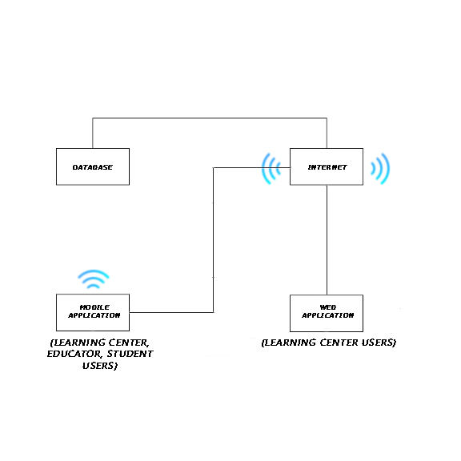 The model of the network shows how the system components communicate via the internet. The diagram shows that the user is able to check and monitor their account through application for possible breaches or errors.

Figure 40: **Network Model**

Figure 40 shows the network model of the system. Internet is used for mobile app to interact with the database.

**Network Topology**

The network topology illustrates how the system's component work in conjunction with the use of internet connection to access the user's access database.

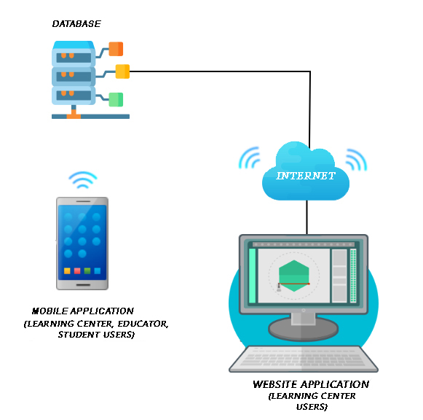

Figure 41: **Network Topology**

Figure 41 shows the network topology of the system. As shown, the user can use mobile app with the help of the internet. They can manage classes, check schedules, post and search jobs, etc. For the web app, the learning center can manage classes, check schedules, post and search jobs, etc.

**Development/Construction/Build Phase**

The Development Phase marks the end of the initial process segment and marks the beginning of development. This phase is intended to turn the prototyped system design in the Design Phase into a working system that meets all defined system requirements. Two elements are required to complete this phase successfully: 1) a complete set of design specifications and 2) proper processes, standards and tools.

**Technology Stack Diagram**

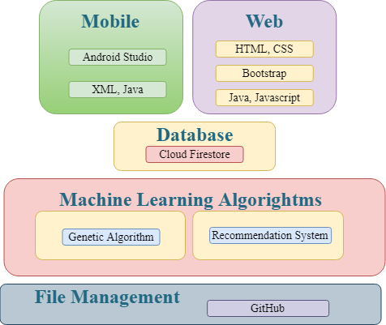

Figure 42: **Technology Stack Diagram**

Figure 42 shows the technology stack diagram representing the different technologies the project uses and the purpose for each specific language.

**Android Studio** is an integrated development environment for the Android operating system. It was built on JetBrains' IntelliJ IDEA software and designed for android development. It comprises both frontend and backend development by using XML and java.

**XML**,meaning eXtensible Markup Language, is a markup language built as a standard way to encode data in internet-based applications. Android uses it in creating layouts and components as Front End for typical applications.

**Java** is one of the languages used in android development. Java's mobile version is called Java ME. Many smartphones and tablets support it. The Java Platform Micro Edition (Java ME) provides a flexible, secure environment for building and running applications that target embedded and mobile devices. Java ME addresses the challenge of running applications on devices that are low on memory, display, and power available.

**Cloud Firestore** is a repository of NoSQL documents designed for automatic scaling, high performance, and ease of application development.

**Genetic Algorithm** is a search heuristic based on Charles Darwin's theory of natural evolution. The algorithm reflects the natural selection process in which the most suitable individuals are selected for reproduction to produce the next-generation offspring. It consists of five phases–initial population, fitness function, selection, crossover, and mutation.

**Recommendation system** is a group of machine learning algorithms that strives to predict user preferences and make suggestions that clients would be interested in. It has two approaches to making recommendations–collaborative filtering and content filtering. Collaborative filtering involves comparing the behavior of similar groups to predict what a user, with likely behaviors, would want. Meanwhile, content filtering is based on a description of the item and a profile of the user's preferences.

**GitHub** is a system used to store a project's source code and record any modifications to that code in its entire history. It allows developers to work more efficiently on a project by providing resources from different developers to manage potentially conflicting changes.

**Cloud Storage for Firebase** is a storage service built for Google scale that enables users to store files as well as uploads ensured with Google security.

**Firebase Cloud Messaging** is a cross-platform messaging solution that lets you reliably send messages at no cost.

**Bootstrap** is a free and open-source front end development platform for website and web app construction. The architecture for Bootstrap is based on HTML, CSS, and JavaScript (JS) to promote the development of responsive, first mobile sites and apps.

**HTML**, or HyperText Markup Language, is the standard markup language for creating Web pages. It describes the structure of a Web page. Consisting of a series of elements or tags, it tells the browser how to display content.

**CSS**, short for Cascading Style Sheets, a new feature introduced to HTML that provides more control over how pages present to both website developers and users.

**JavaScript** is a scripting language on the client-side. It means that the web browser of the client interprets the source code instead of the webserver. JavaScript functions can run without interacting with the server after a web page loads.

**Software Specification**

The software specification describes the functional requirements of the study. It includes the programming language, platform for development, management of the database, and machine learning algorithms.

The mobile development uses Android Studio IDE with Java being the back end programming language, and XML for front end builds. The mobile application is for Android devices. The development uses minimum API Level 21to run with devices Android 5.0 and higher. The researchers decided with the minimum API based on the worldwide Android version distribution, according to Holst (2019) and Protalinski (2019), where roughly 90% of devices running in Android have versions 5.0 and higher.

Genetic algorithm is the preferred machine learning algorithm to use for scheduling classes. Making of class schedules are NP-hard problems and does not have a definite correct answer, only an optimal one. The heuristic approach is usually enough for simple cases but with the complexity of the system. It is decided to go with a Genetic Algorithm for a better solution.

The hiring module makes use of Recommendation systems to efficiently suggest a list of qualified job seekers to a learning center with job vacancies and a list of job vacancies to a job seeker. Content-filtering is the initial approach to the small dataset until such time when collaborative filtering can add to the efficiency of the recommendations.

Cloud Firestore is the database of choice to support the project. Both mobile and web application connects to Firestore for all data. GitHub supports the collaboration of the members and allows them to code concurrently for more efficient and time-conscious development.

**Program Specifications**

Program specifications contain the list of algorithms needed for the system.

Table 26

SOFTWARE LIST OF MODULES

|  |  |  |  |  |
| --- | --- | --- | --- | --- |
| **Programmer/s** | **Modules** | **Learning Center** | **Educator** | **Parent or Student** |
| Jephunneh  Rhea Shane  Cristian  John Rey | **Account Management** |
| 1. Registration | * | * | * |
| 2. Authentication | * | * | * |
| 3. Login | * | * | * |
| 4. Profiling | * | * |  |
| No. of Points *(1 point per module per user)* | | 1 | 1 | 1 |
| Jephunneh  Rhea Shane  Cristian  John Rey | **Hiring Module** |  | | |
| 1. Hiring Profile/Resume |  | * |  |
| 2. Job Searching |  | * |  |
| 3. Job Post Management | * |  |  |
| 4. Job Suggestion |  | * |  |
| 5. Hire Suggestion | * |  |  |
| 6. Hiring | * |  |  |
| 7. View Applicants | * |  |  |
| 8. View Hired | * |  |  |
| 9. View Rejected | * |  |  |
| No. of Points *(1 point per module per user)* | | 1 | 1 | 0 |
| Jephunneh  Rhea Shane  Cristian  John Rey | **Enrollment Module** |  | | |
| 1. Input/Add Course Details | * |  |  |
| 2. Search/Display Course List | * | * | * |
| 3. Course Selection |  |  | * |
| 4. Fee Calculation |  |  | * |
| 5. Enrollment Details and Processes |  |  | * |
| 6. Payment Scheme Selection |  |  | * |
| 7. Payment |  |  | * |
| 8. Record Payment | * |  | * |
| No. of Points *(1 point per module per user)* | | 1 | 1 | 1 |
| Jephunneh  Rhea Shane  Cristian  John Rey | **Scheduling Module** |  | | |
| 1. Input Class Details | * |  |  |
| 2. Update Class Details | * |  |  |
| 3. Input Schedules | * |  |  |
| 4. Schedule Request |  | * | * |
| 5. Update Schedules | * |  |  |
| 6. Generate Calendar of Activities | * | * | * |
| 7. Notification of Changes | * | * | * |
| No. of Points *(1 point per module per user)* | | 1 | 1 | 1 |
| Number of Modules per User *(equals total no. of points per user)* | | 4 | 4 | 3 |
| Total Number of Modules | | 11 | | |

Table 26 shows the comparison of the access level of each type of account. The table shows that multiple types of accounts or a specific type of account can access a module. It also shows the programmer/s assigned to develop per module.

**Testing/Quality Assurance Phase**

The Quality Assurance Phase is a way of preventing mistakes and defects in deployed applications and avoiding problems when delivering them to customers. It is part of quality management focused on providing confidence that quality requirements will be fulfilled.

**Unit Testing**

UNIT TESTING is a level of software testing where individual units/ components of a software are tested. The purpose is to validate that each unit of the software performs as designed. A unit is the smallest testable part of any software. It usually has one or a few inputs and usually a single output.

Table 27

UNIT TESTING – LEARNING CENTER APPLICATION

|  |  |  |  |  |  |  |  |
| --- | --- | --- | --- | --- | --- | --- | --- |
| **Module Name** | **Unit Name** | **Date Tested** | **Test Case ID** | **Test Case Description** | **Expected Results** | **Actual Results** | **Remarks** |
| Account Management | Registration | 12/27/2020 | LC1 | All files are filled out and Valid | Proceed tto next step | Performed as expected | Passed |
| Account Management | Registration | 12/27/2020 | LC2 | All fields are filled out and invalid | Prompt user to input information in the missing field | Performed as expected | Passed |
| Account Management | Registration | 12/27/2020 | LC3 | Some fields are not filled out | Prompt user to input information in the missing field | Performed as expected | Passed |
| Account Management | Registration | 12/27/2020 | LC4 | All fields are not valid | Prompt user to input correct information basing from requirements | Performed as expected | Passed |
| Account Management | Authentication | 12/27/2020 | LC5 | Upload documents | Valid Business Permit | Performed as expected | Passed |
| Account Management | Login | 12/27/2020 | LC6 | Log In as Learning Center Admin | Successful Login | Performed as expected | Passed |
| Hiring Module | Job Posting | 12/27/2020 | LC7 | Create new Job | Successfully created Job | Performed as expected | Passed |
| Hiring Module | Hiring | 12/27/2020 | LC8 | View Applicants and Resume from ‘Applicants tab’ | List of applicants available | Performed as expected | Passed |
| Hiring Module | Hiring | 12/27/2020 | LC9 | Hire Applicant | Successfully hired applicant | Performed as Expected | Passed |
| Account Management | Profiling | 12/27/2020 | LC10 | Upload User Profile Photo | Successfully added photo | Performed as expected | Passed |
| Account Management | Profiling | 12/27/2020 | LC11 | Edit Name | First and Last Names can be edited | Performed as Exp;ected | Passed |
| Account Management | Profiling | 12/27/2020 | LC12 | Input complete address | Successfully added complete address | Performed as Expected | Passed |
| Account Management | Profiling | 12/27/2020 | LC13 | Leave Required Fields Empty | Prompts user to input details | Performed as Expected | Passed |
| Account Management | Registration | 12/27/2020 | LC14 | Create new LC user | Input required details and create user | Performed as Expected | Passed |
| Account Management | Profiling (Learning Center) | 12/27/2020 | LC15 | Leave Required Fields Empty | Prompts user to input details | Performed as Expected | Passed |
| Account Management | Profiling (Learning Center) | 12/27/2020 | LC16 | Upload Learning Center Profile Photo | Successfully added photo | Performed as Expected | Passed |
| Enrollment Module | Input/Add Course Details | 12/27/2020 | LC17 | Add course details on created course | Successfully added details | Performed as Expected | Passed |
| Enrollment Module | Search/Display Course List | 12/27/2020 | LC18 | View posted course list | Able to view all posted courses from ‘Enrollment tab’ of LC profile | Performed as Expected | Passed |
| Enrollment Module | Record Payment | 12/27/2020 | LC19 | Receive and record payment | Able to view, receive and record payments | Performed as Expected | Passed |
| Scheduling Module | Input Class Details | 12/27/2020 | LC20 | Create new course/class | Able to create new course/class | Performed as Expected | Passed |
| Scheduling Module | Update Class Details | 12/27/2020 | LC21 | Modify class details | Able to edit posted class details | Performed as Expected | Passed |
| Scheduling Module | Input Schedule | 12/27/2020 | LC22 | Enter/set class schedule | Able to specify schedule of classes/courses | Performed as Expected | Passed |
| Scheduling Module | Update Schedules | 12/27/2020 | LC23 | Modify class schedule | Able to modify class schedules | Performed as Expected | Passed |

Table 28

UNIT TESTING – EDUCATOR APPLICATION

|  |  |  |  |  |  |  |  |
| --- | --- | --- | --- | --- | --- | --- | --- |
| **Module Name** | **Unit Name** | **Date Tested** | **Test Case ID** | **Test Case Description** | **Expected Results** | **Actual Results** | **Remarks** |
| Account Management | Registration | 12/28/2020 | ED1 | All files are filled out and Valid | Proceed to next step | Performed as expected | Passed |
| Account Management | Registration | 12/28/2020 | ED2 | All fields are filled out and invalid | Prompt user to input information in the missing field | Performed as expected | Passed |
| Account Management | Registration | 12/28/2020 | ED3 | Some fields are not filled out | Prompt user to input information in the missing field | Performed as expected | Passed |
| Account Management | Registration | 12/28/2020 | ED4 | All fields are not valid | Prompt user to input correct information basing from requirements | Performed as expected | Passed |
| Account Management | Login | 12/28/2020 | ED5 | Log In as Educator | Successful Login | Performed as expected | Passed |
| Account Management | Profiling | 12/28/2020 | ED6 | Upload User Profile Photo | Successfully added photo | Performed as expected | Passed |
| Account Management | Profiling | 12/28/2020 | ED7 | Update Account | Successfully Updated account | Performed as Expected | Passed |
| Account Management | Profiling | 12/28/2020 | ED8 | Update Profile | Successfully Updated Profile | Performed as Expected | Passed |
| Hiring Module | Resume | 12/28/2020 | ED9 | Update Resume | Successfully Updated Resume | Performed as Expected | Passed |
| Hiring Module | Job Searching | 12/28/2020 | ED10 | Search for Jobs | Successfully searched for posted jobs based on LC name and keywords | Performed as Expected | Passed |
| Enrollment Module | Search/Display Course List | 12/28/2020 | ED11 | Display Courses | Successfully viewed courses | Performed as Expected | Passed |
| Scheduling Module | Schedule Request | 12/28/2020 | ED12 | Request change of class schedule | Able to request change of schedule from LC | Performed as Expected | Passed |
| Scheduling Module | Notification Changes | 12/28/2020 | ED13 | Receive notification of schedule change | Able to receive notification | Performed as Expected | Passed |

Table 29

UNIT TESTING - STUDENT APPLICATION

|  |  |  |  |  |  |  |  |
| --- | --- | --- | --- | --- | --- | --- | --- |
| **Module Name** | **Unit Name** | **Date Tested** | **Test Case ID** | **Test Case Description** | **Expected Results** | **Actual Results** | **Remarks** |
| Account Management | Registration | 12/29/2020 | PS1 | All files are filled out and Valid | Proceed tto next step | Performed as expected | Passed |
| Account Management | Registration | 12/29/2020 | PS2 | All fields are filled out and invalid | Prompt user to input information in the missing field | Performed as expected | Passed |
| Account Management | Registration | 12/29/2020 | PS3 | Some fields are not filled out | Prompt user to input information in the missing field | Performed as expected | Passed |
| Account Management | Registration | 12/29/2020 | PS4 | All fields are not valid | Prompt user to input correct information basing from requirements | Performed as expected | Passed |
| Account Management | Login | 12/29/2020 | PS5 | Log In as Student | Successful Login | Performed as expected | Passed |
| Account Management | Profiling | 12/29/2020 | PS6 | Upload User Profile Photo | Successfully added photo | Performed as expected | Passed |
| Account Management | Profiling | 12/29/2020 | PS7 | Update Account | Successfully Updated account | Performed as Expected | Passed |
| Account Management | Profiling | 12/29/2020 | PS8 | Update Profile | Successfully Updated Profile | Performed as Expected | Passed |
| Enrollment Module | Search/Display Course List | 12/29/2020 | PS9 | View All Courses available | Able to View posted courses | Performed as Expected | Passed |
| Enrollment Module | Course Selection | 12/29/2020 | PS10 | Select/Enrol specific courses/classes | Able to select classes and enrol | Performed as Expected | Passed |
| Enrollment Module | Payment | 12/29/2020 | PS11 | Enrol in a class and submit proof of payment | Able to enrol and attach proof of payment | Performed as Expected | Passed |
| Enrollment Module | Record Payment | 12/29/2020 | PS12 |  |  |  |  |
| Scheduling Module | Schedule Request | 12/29/2020 | PS13 | Submit Class Schedule Request | Able to modify date/time and submit request to LC | Unable to modify start time | Failed |
| Scheduling Module | Notification Changes | 12/29/2020 | PS14 | Receive notification of schedule change | Able to receive notification | Performed as Expected | Passed |

**Integration Testing**

INTEGRATION TESTING is a level of software testing where individual units are combined and tested as a group. The purpose of this level of testing is to expose faults in the interaction between integrated units. Test drivers and test stubs are used to assist in Integration Testing.

Table 30

INTEGRATION TESTING

|  |  |  |  |  |  |
| --- | --- | --- | --- | --- | --- |
| **Test Case ID** | **Module** | **Integration Process** | **Pre-condition** | **Result** | **Remarks** |
| 1 | Account Management (LC, Educator, Parent/Student) | Input valid and correct information | Users are successfully registerd | Performed Expected Result | Passed |
| 2 | Account Management (LC, Educator, Parent/Student) | Authentication | Email Required | Email Address will be validated | Passed |
| 3 | Account Management (LC, Educator, Parent/Student) | Login | Login Page | Will be redirected to profile | Passed |
| 4 | (LC, Educator, Parent/Student) | Profiling | User successfully logged in | Can Update Profile/Resume/Account | Passed |
| 5 | Hiring Module | Job Search | Must be logged into Educator Account | By default, all job posts are listed. Educators are able to search job by LC name or by keywords. | Passed |
| 6 | Hiring Module | Job Posting | Must be logged into LC Admin account | Able to post Job | Passed |
| 7 | Hiring Module | Job Suggestion | Must be logged into Educator Account |  | Passed |
| 8 | Hiring Module | Hire Suggestion | Must be logged into LC Admin account) | Can view list of applicants ‘Applicants’ | Passed |
| -9 | Hiring Module | Hiring | Must be logged into LC Admin account | Can hire educator from list of applicants | Passed |
| 10 | Enrollment | Add Course | Must be logged into LC Admin account | Able to post new course/class | Passed |
| 11 | Enrollment | Search/Display Courses | User must be logged in successfully | Users can view list of courses | Passed |
| 12 | Enrollment | Course Selection | User must be logged in successfully | Able to select course and enrol | Passed |
| 13 | Enrollment | Payment/ Record Payment | Must be logged into LC Admin account. Enrol to an existing course/class. | Enrollment requires proof of payment. | Passed |
| 14 | Scheduling | Input Class Details | Must be logged in to LC admin account | Able to enter class description | Passed |
| 15 | Scheduling | Update Class Details | Must be logged in to LC admin account | Able to update class description | Passed |
| 16 | Scheduling | Input Schedules | Must be logged in to LC admin account | Able to specify class schedule | Passed |
| 17 | Scheduling | Schedule Request | Must be logged in to Educator or Student account | Able to send a request of schedule change to Learning Center | Passed |
| 18 | Scheduling | Update Schedules | Must be logged in to LC admin account | Able to modify class Schedule. Mostly, after a schedule request | Passed |
| 19 | Scheduling | Generate Calendar of Activities | User logged in successfully | Able to view scheduled activities based on user’s classes | Passed |
| 20 | Scheduling | Notification of Changes | User logged in successfully | Able to receive notificatoin of class changes | Passed |

**Alpha Testing**

Alpha testing is the initial phase of validating whether a new product will perform as expected. Alpha tests are carried out early in the development process by internal staff and are followed up with [beta tests](https://whatis.techtarget.com/definition/beta-test), in which a sampling of the intended audience actually tries the product out.

Table 31

ALPHA TESTING

|  |  |  |  |  |
| --- | --- | --- | --- | --- |
| **Test Criteria** | **Poor** | **Fair** | **Good** | **Very Good** |
| Graphical User Interface (GUI) | | | | |
| Consistency (The user interface is of the same formatting style and icons throughout the system.) |  |  |  |  |
| Reusability (The system contains reusable GUI components such as familiar buttons, text and checkboxes, and other tools.) |  |  |  |  |
| Forgiveness and Tolerance (The interface displays message or confirmation prompts that would allow the users to undo or redo critical actions.) |  |  |  |  |
| Simplicity (The GUI design include simple GUI buttons, such as simple screens with clear, uncrowded messages.) |  |  |  |  |
| Readability (The interface has appropriate colors, font sizes, and styles that is convenient to the target users.) |  |  |  |  |
| Clarity (Displayed error, help, and warning messages are clear, concise, and as elementary as possible to assist user in operating the software.) |  |  |  |  |
| Flexibility (The system includes user preferences settings to allow changes, for example, increasing the font size.) |  |  |  |  |
| User-friendliness (The GUI design must be user-friendly, by providing helpful, courteous, and non-offending messages.) |  |  |  |  |
| System Performance | | | | |
| Conformance to the Requirements (The system effectively met all the identified features and/or requirements.) |  |  |  |  |
| Conformance to the Objectives (All specific objectives of the system are met by the program.) |  |  |  |  |
| Efficiency (The entire system functions efficiently. It doesn’t have delay in any transaction.) |  |  |  |  |
| Security (The system is secured. Login details are authenticated. Input parameters are ensured prior to the execution of the next transaction.) |  |  |  |  |
| Integrity (The software allows the registered user to have control over its own private information.) |  |  |  |  |
| Overall Impression (In general, the program or system is functional and useful.) |  |  |  |  |

**Acceptance Testing**

ACCEPTANCE TESTING is a level of software testing where a system is tested for acceptability. The purpose of this test is to evaluate the system's compliance with the business requirements and assess whether it is acceptable for delivery.

Table 32

ACCEPTANCE TESTING

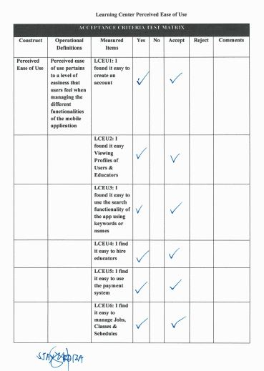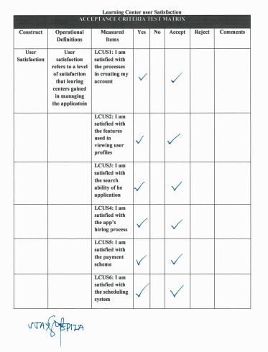

Table 32.1

ACCEPTANCE TESTING CONT’D

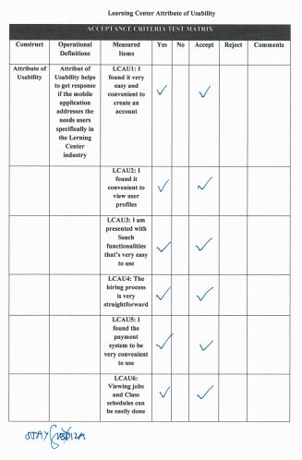 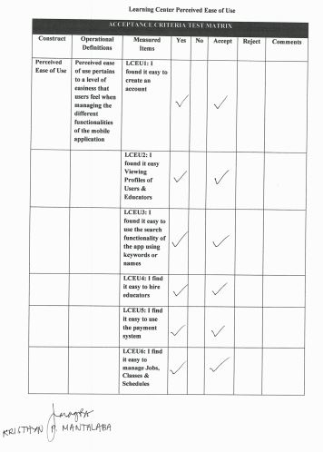

Table 32.2

ACCEPTANCE TESTING CONT’D

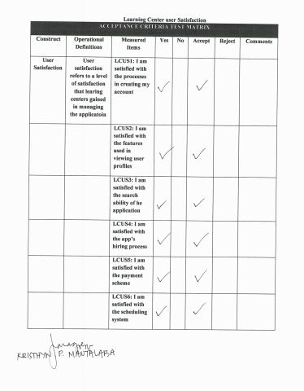 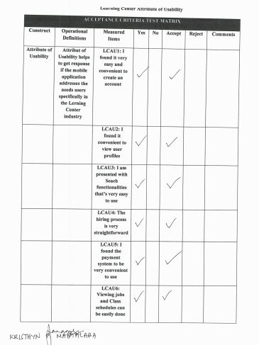

Table 32.3

ACCEPTANCE TESTING CONT’D

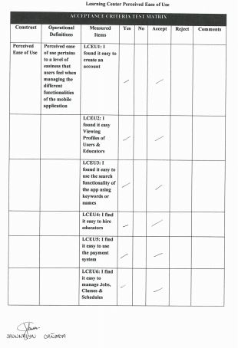 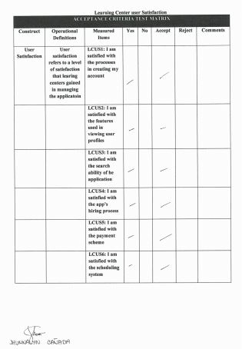

Table 32.4

ACCEPTANCE TESTING CONT’D

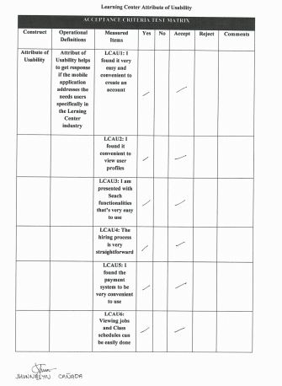 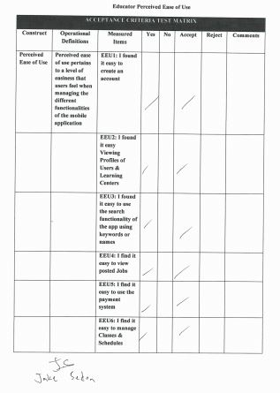

Table 32.5

ACCEPTANCE TESTING CONT’D

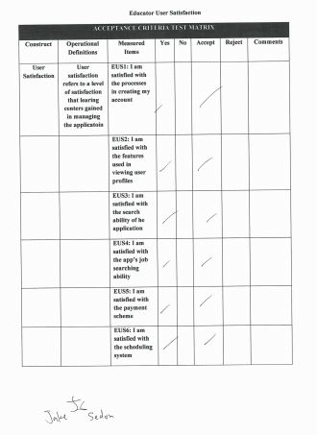 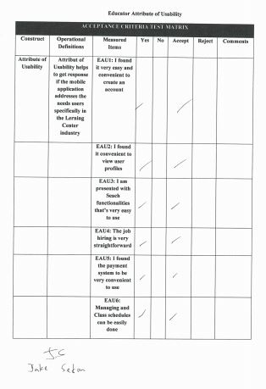

Table 32.6

ACCEPTANCE TESTING CONT’D

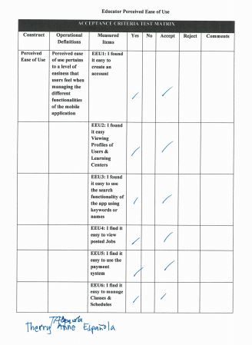 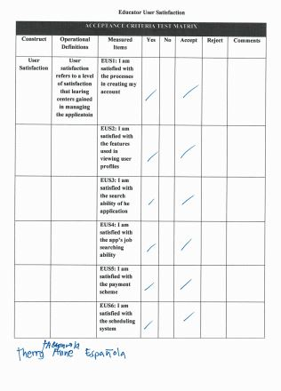

Table 32.7

ACCEPTANCE TESTING CONT’D

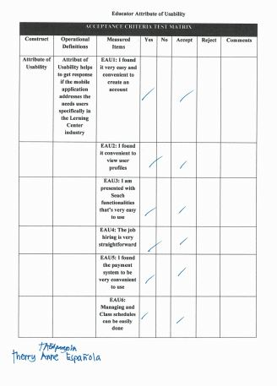 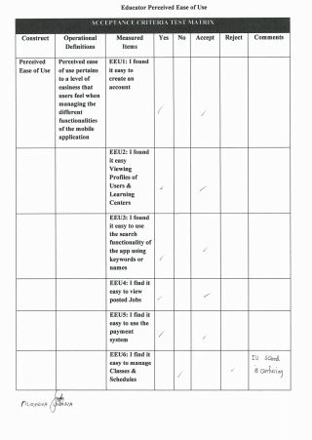

Table 32.8

ACCEPTANCE TESTING CONT’D

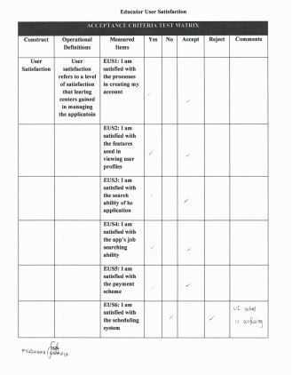 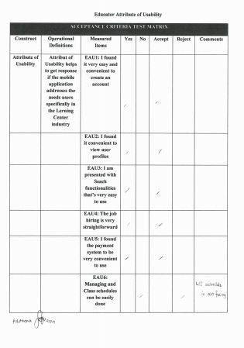

Table 32.9

ACCEPTANCE TESTING CONT’D

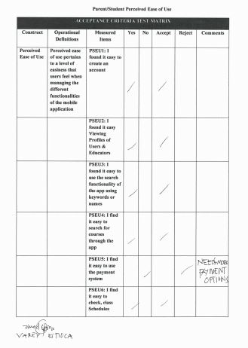 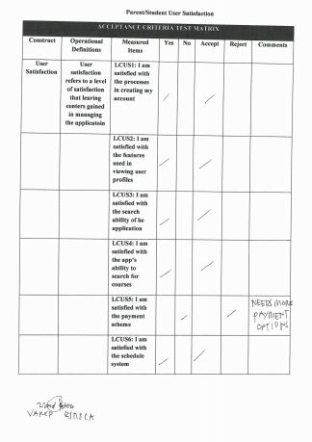

Table 32.10

ACCEPTANCE TESTING CONT’D

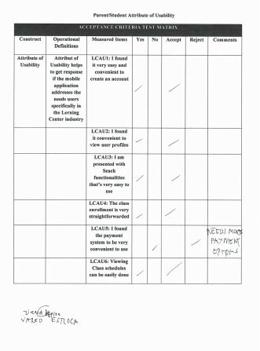 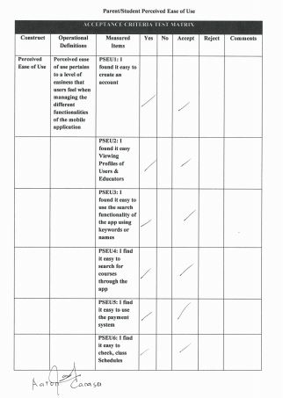

Table 32.11

ACCEPTANCE TESTING CONT’D

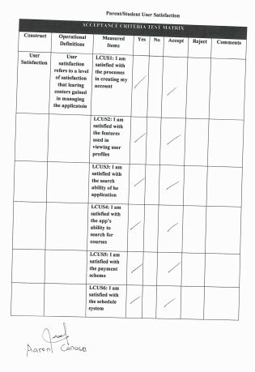 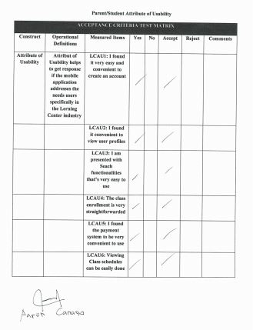

**IMPLEMENTATION/DEPLOYMENT PHASE**

**Costs Specification**

The costs of developing a formal specification are the costs of the time required for skilled engineers to understand the system requirements, choose an appropriate approach to specification and develop a formal model of the system. Developing and analyzing a formal specification front-loads software development costs.

|  |  |
| --- | --- |
| Expense | Cost |
|  |  |

**Software Specification**

A software requirements specification (SRS) is a description of a software system to be developed. Software requirements specifications can help prevent software project failure. The software requirements specification document lists sufficient and necessary requirements for the project development.

Table 33

Software Requirements Specifications

|  |  |
| --- | --- |
| Database | Firebase |
| Text Editing Tool | Sublime, Notepad++ |
| Image Editing Tool | Adobe Photoshop CS3 or Higher |
| Eclipse | Oxygen |
| Android SDK | SDK 5.0 |
| Java JDK | Version 12 |
| Android Development Tool (ADT) Plug in | Latest Version |

**Hardware Specifications**

Table 34

Hardware Specifications

|  |  |
| --- | --- |
| Android-Based Application | CPU: at least 800 MHz or higher  GPU: at least 800 MHz or Higher  Wi-Fi enabled OS: at least Android 5.0 (Lollipop, API 21)  Memory: at least 256 phone memory and at least 1 GB for memory card |

**Human Resource Specifications**

This section shows the different users that are involved in using iLearnCentral app. These users are the Learning Center Admin and created users, Hired and Job-seeking Educator, and Student whom can only use the application once verified.

Table 35

Hardware Resource Specifications

|  |  |
| --- | --- |
| **USER** |  |
| Learning Center | The learning centers can create other users that will handle the processes whilst the admin is not active. Also, they can create a job posting indicating their need of their preferred educator to work for them. While accepting educators’ application forms, they can view educator’s personal information from the created account of job-seeking educators. Lastly, the learning center can create an enrollment of subject in which students can view and enroll to upon requirement of the educator. |
| Educator | Like the learning centers, the educator can create an account as to register their account to the learning center they belong to, or as a job-seeking educator finding opening jobs from learning centers. Also, the educator can view postings/updates from the learning center they chose to follow/notified from. |
| Student | The student can create an account provided that they are required by the educator/learning center admin. The student can view updates from the learning center they are accounted with and courses they are enrolled to. |

**User Guide**

User guide provides instructions on how to use iLearnCentral application and how to navigate and operate the app.

Log in Page – This is where the user of the application needs to input their credentials in order to use the application.

Tap Forgot Password if you have forgotten your password and wait for an email to reset it

Tap Sign Up if you’re a new user



Input username or a valid email and password if you already have an existing account in the application. Then after inputting tap Log In.

Figure 43: **Log In Page**

Account Type Selection Page – This is where the new user of the application gets to choose the type of account type he’ll be using in the application.

After clicking Sign Up, the user may choose which account type he’ll be using. He just needs to tap from one of these and choose what type of account he’s signing up for, whether it is Learning Center account, an Educator account or a Student account.



Figure 44: **Account Type Selection Page**

Sign- Up Page – This shows the different Sign Up page for the different type of users of the application. It is where the specific information needed for each account should be provided in order to make the account.

Learning Center Sign up Form

Input all the information needed such as business name, the website of the learning center, the email address and active contact number they’re using where the students may contact them, a small description about the learning center and lastly the address



Educator Sign up Form

Input all the information needed such as the educator’s first name, middle name, last name, his marital status, gender, birth date, citizenship, religion and his home address



User Sign up Form

Input all the information needed such as the username, password, valid email address and contact number and lastly choose a security question to secure the account.



Figure 45: **Sign Up Page**

Learning Center User Interface- This shows the profile of the learning center, its information about, feed or posts about existing learning centers, job posting from the learning centers, enrollment where subjects are posted, educators page where educators information are can be seen, classes page where subjects and its corresponding educators are presented with the complete details like the schedule for the class. A search button at the top where the user can search anyone that uses tha application, an enrollment button, a notification bell to notify the user of any activity or action and the messages.

Learning Center Profile Page

Notification button where the user will be notified whatever activity or action

Enrolment button for the user to choose what subjects to enroll from a certain learning center

Search button where the user can search anyone that’s registered to the application whether it is a Learning Center User or an Educator

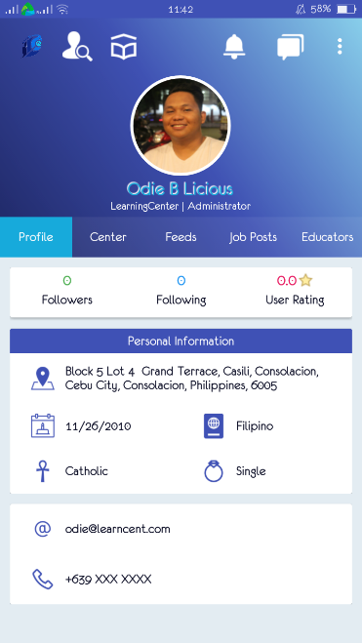

Shows the personal information about the learning center which includes the number of followers of the center, the number of how many accounts the center has been following and lastly the ratings of the center

Learning Center About Center Page

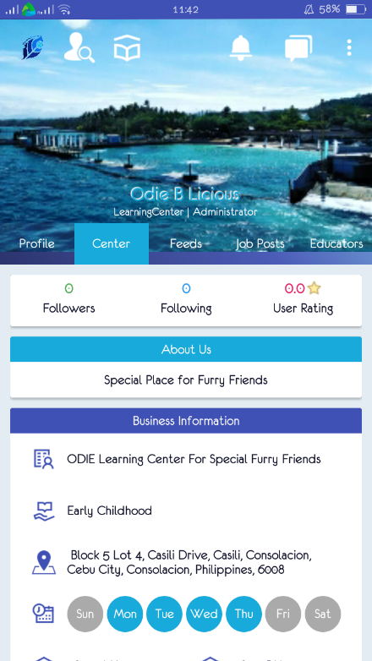

Shows the business information about the learning center which includes the name, business information, its address and their business schedule

Learning Center Feed Page

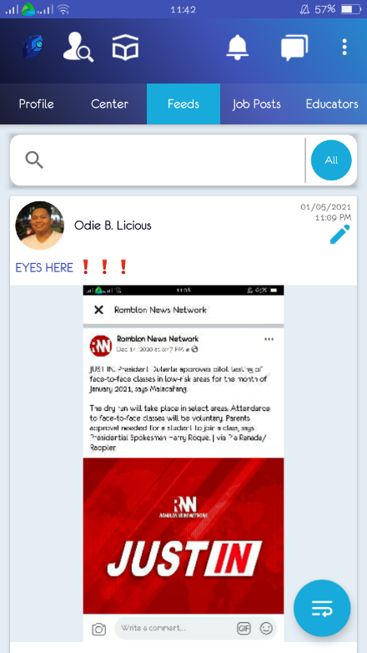

Shows the feed or posts from the different existing learning centers from the application.

User may also input in the search bar of any topic he wants to look for that may already be posted from other learning centers

Learning Job Posts Page

Shows the job postings from different learning centers

User may also input in the search bar of any job types from different learning centers

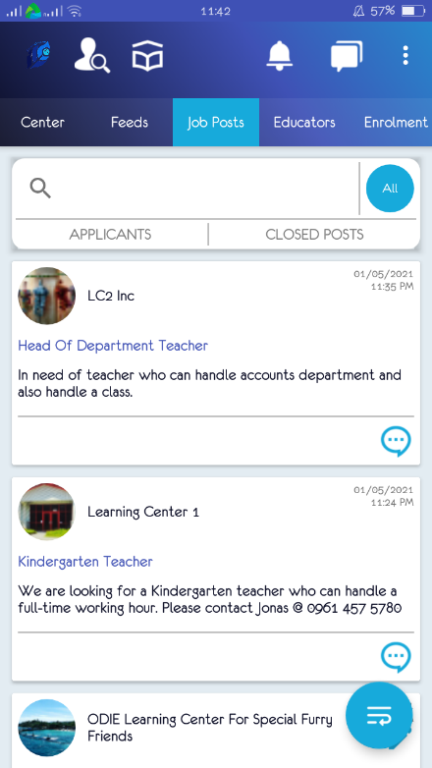

Learning Center Enrollment Page

This is where subjects are posted together with the corresponding schedule to which students will be able to choose for them to enroll

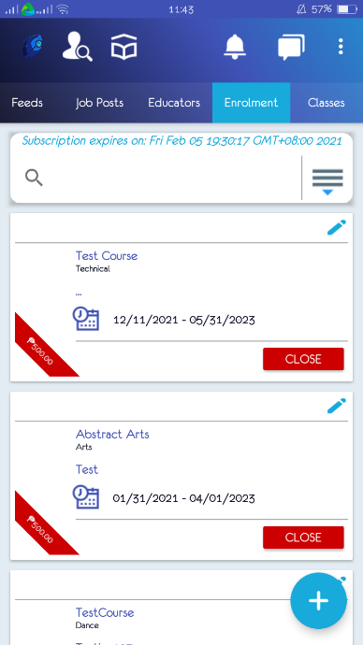

Learning Center Educators Page

This will show all the employed educators of that certain Learning Center user, where status and information of an educator can be seen

User may input a name an educator, their status or any certain information and results will be shown below depending from the searched keyword inputted in the search bar

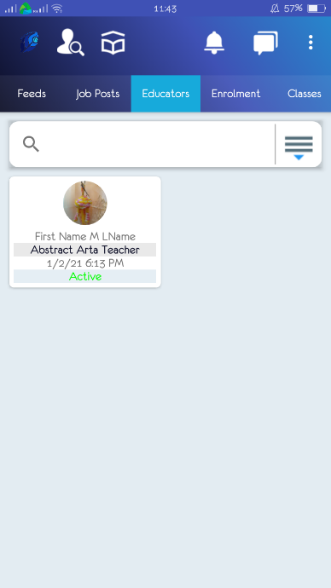

Learning Center Classes Page

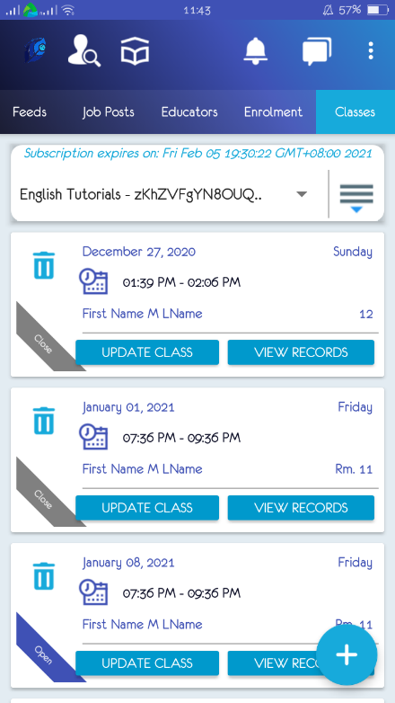

All the classes with the subjects with its corresponding educators will be shown in this part of the classes page

Learning Center Enrollment and Scheduling Subscription Page

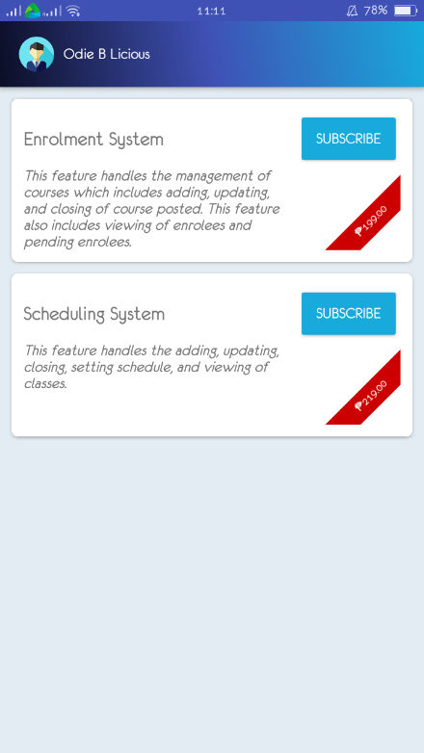

Users may tap subscribe to in order to avail other services the system offers such as adding, updating, and closing of course posted, also the viewing of the overall enrollees and the pending enrollees and the scheduling system which includes adding, updating, and setting schedule of classes

Learning Center Search Page

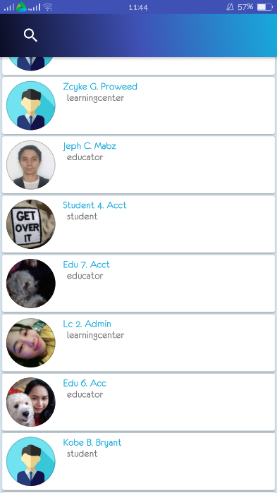

Search button where the user can search anyone who is registered to the application whether it is a Learning Center User or an Educator

Learning Center Recommended Learning Center Page

Users may input names or keywords that will result to the Learning Center they’re interested in to

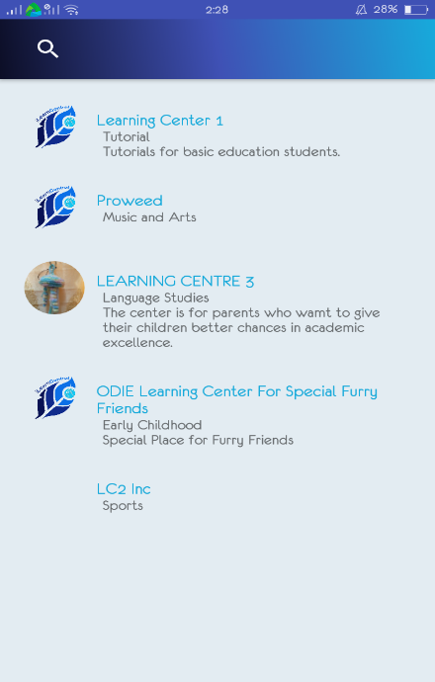

Learning Center samples will be shown here based from the keywords or names searched from the search bar above

Learning Center Sidenav Page

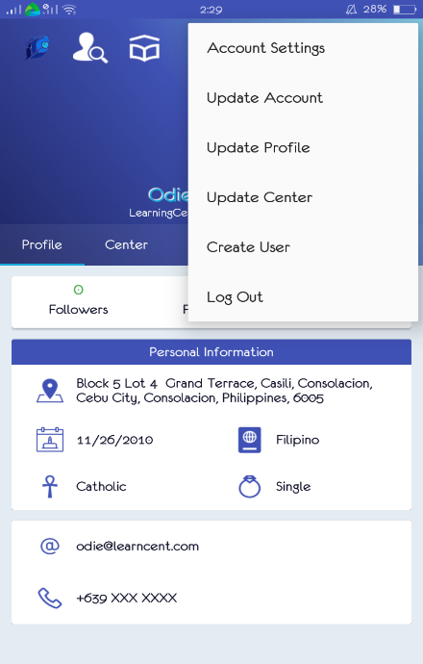

Other options of what the user wanted to do to his account on the system are visible in this part of the page, he may go to the settings account to change anything he wanted, update his account or profile, update the center or create a new user and lastly if the user’s done using with the system, just click Log out

Figure 46: **Learning Center User Interface**

Educator User Interface - This shows the educators profile page, its information about or feed from the different learning centers or educators, the job posting where details such as job name or job description can be seen and to where or what learning center it is from, the educator’s classes page where the subjects and its scheduled time and day can be seen and lastly the search bar and the message button where an educator may send message to anyone and may able to received a message to whoever is authorized for them to message to.

Educator Profile Page

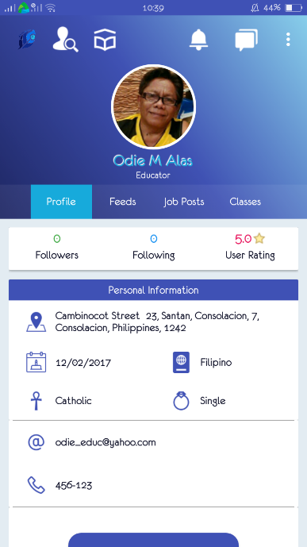

Shows the personal information about the educator which includes the number of followers of the educator, the number of how many accounts the educator has been following and lastly the ratings of him as an educator. This is where the educator user can edit its information, in his profile where his personal information is can be seen, like his address, birth date, religion, citizenship, marital status, email address, contact number and educational background. His status may also be seen whether he is already employed to a certain learning center

Search button where the user can search anyone that’s registered to the application whether it is a Learning Center User or an Educator

Enrolment button for the user to choose what subjects to enroll from a certain learning center

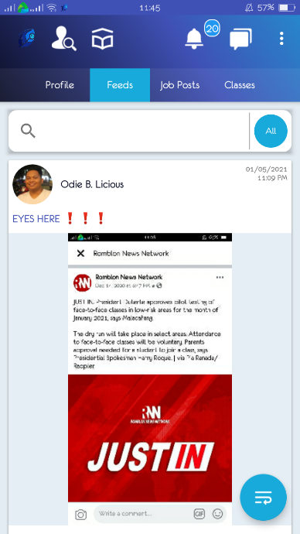Educator Information Feeds Page

Educator users will be able to view any updates from the different learning centers or from its fellow educators from his feeds page

Educator Job Posting Page

Different job posting from the learning centers can be viewed by the educators registered in the application from here



User may also contact the employer of the said job just by sending them a message

Educator Classes Page

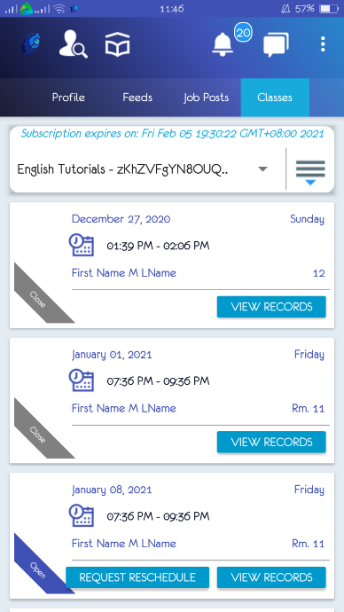

All the classes by the educator user will be shown here with its corresponding details such as the subject’s name and its time and days it is scheduled.

Educator Search Page

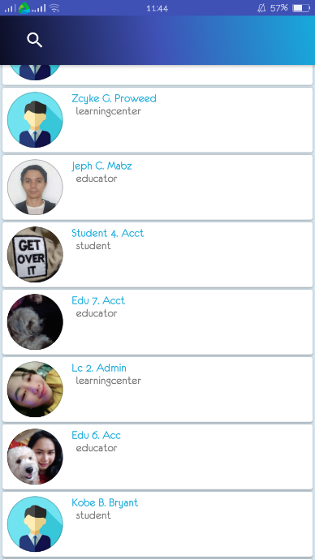

Search button where the user can search anyone that’s registered to the application whether it is an Educator or a Learning Center

Sample registered users of the application shown by the system

Educator Learning Center Page

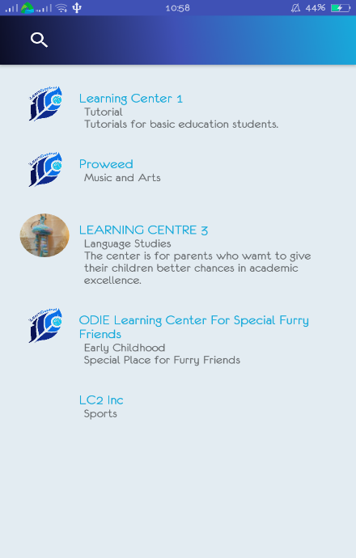

Educator user may also view different learning centers with its complete name, location, description and all the necessary details

Educator Message Page



Educator user may send messages to all members that are only authorized for them to send a message to

Figure 47: **Educator User Interface**

Student or Parent User Interface - This shows the profile of the student or the parent, its information feed or posts about existing learning centers or edcators , the courses page , the classes page where different classes from different educators or learning centers are posted. A search button at the top is also visible where the user can search anyone that’s registered in the system and lastly the recommended learning centers for the student or parents cant also be viewed.

Student or Parent Profile Page

Shows the personal information about the student or parent which includes the number of followers of the student or parent, the number of how many accounts the student or parent has been following and lastly the ratings of him as a user. This is where the student or parent user can edit its information, in his profile where his personal information is can be seen, like his address, birth date, religion, citizenship, marital status, email address and contact number

Message button where user can see any messages, may it be from the learning center an educator or another student

Search button where the user can search anyone that’s registered to the application whether it is a Learning Center User or an Educator

Notification button where the user will be notified whatever activity or action

Enrolment button for the user to choose what subjects to enroll from a certain learning center



Student or Parent Information Page



Information feed that will show other posts by other students or parents they are updated or anybody they’re following

Student or Parent Courses Page

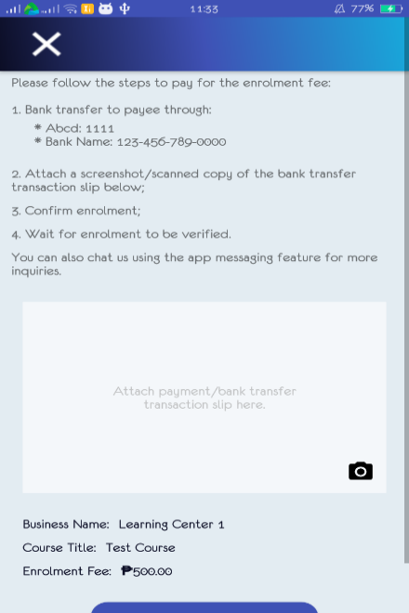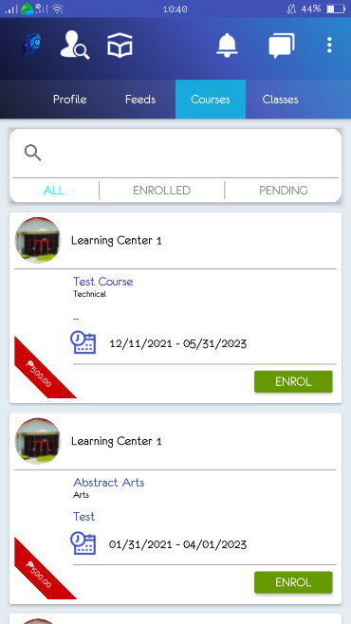

Student user will tap enroll if he wanted to take the course

This is where the Student user may view all the courses that’s intended for them to enroll or that’s instructed by the learning center

Student or Parent Classes Page



This is where the Student user can view all of its classes throughout the day. Information such as the subject name and the schedule of each subjects are shown

Student or Parent Search Page



Search button where the user can search anyone that’s registered to the application whether it is a Learning Center User or an Educator

Student or Parent Recommended Learning Centers

Users may input names or keywords that will result to the Learning Center they’re interested in to



Learning Center samples in which the user can view all the information he wants to know

Student or Parent Recommended Messages

Users may input names or keywords that will result to the users existing in the application



They can create a message to/from the users they may wish to have a conversation with

Figure 48: **Student User Interface**

**Installation Guide**

Installation guide provides instructions on how to install iLearnCentral application. For better understanding and comprehension, instructions are provided.

1. For device requirements:

* The application is available for Android Users with operating systems from Versions M (Marshmallow API level 23) to O (Oreo API level 28).
* Device must be connected to the Internet.

1. For installing the application:

* Download the application available on Google Play Store.
* Once downloaded, iLearnCentral is now ready to use.

1. For Learning Center Account:

* iLearnCentral application will ask for necessary documents needed to verify for account access when the user wants to subscribe to the additional services offered by the application. .
* The admin of learning center account can then create users provided that they have already subscribed to the additional service.

**Project Roadmap**

The project roadmap is a high-level, easy-to-understand overview of the important pieces of a project. It shows the projects goals and ambitions.

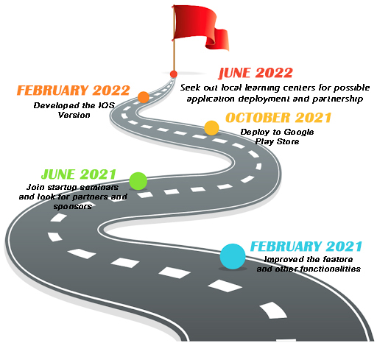

Figure 49: **Project Roadmap**

Figure 49 shows the project’s plans on future innovation of the application for further success in the industry. It shows the steps on what the proponents of the study are planning to make this application a widely known to the likes of learning centers.

**CONCLUSION**

Based on the interviews and online surveys conducted, the project proponents concluded that iLearnCentral will be a great jumpstart program for learning centers to target users, namely learning centers and job-seeking educators. It gives them the technological advantage to boost their promotions and enhancing their services, which leads to increase in revenue. Moreover, iLearnCentral also helps students/parents ease their way in enrollment and scheduling their classes. In addition, mobile application gives customers a great convenience and hassle-free online learning. In result, iLearnCentral is a credible and highly advantageous instrument to all learning centers and aspiring educators in present and the near future.

**RECOMMENDATIONS**

Based from our survey proponents and users’ positive feedback, the application still needs to be upgraded. Several suggestions were given by the users and the following are:

1. iLearnCentral should be able to specify user guides and be friendlier at user interface since the application will be used by a more difficult age span.
2. iLearnCentral should be deployed in the Google Play Store for the application to be more available.
3. iLearnCentral can create more functions in dealing with processing learning centers and educators’ work with technological support.